**Laravel - Framework**

**Programming language:-**

1. Programming language provides raw material for software development.
2. Programming language provides Syntaxes and Symantics for software development.
3. C, C++, Java, C#, Python, PHP, are some popular programming language.

**Software Technology:-**

Software Technology is **Non installable** Softwares, but the softwares developed by using software Technology is installable.

**For Example:-**

**JDBC is non-installable, but Drivers developed by using JDBC are installable.**

**Software Technology is Two types:-**

1. Open Source Technology
2. Closed Source Technology

**Open Source Technology:-**

The Source code of Open Source Technology is available for users, user can modify source code of open source technology.

**E.g. 🡪 Android, PHP, JAVA, Python… are Open Source Technology.**

**Closed Source Technology:-**

The Source Code of closed source technology is not available for users, user can’t modify source code of closed source technology.

**E.g. 🡪 Microsoft .Net, IOS… are Closed Source Technology.**

**Framework**

**Framework:-**

**A framework is installable software and they provide us pre-designed architecture.**

**By using Frameworks you can develop software applications more easily.**

**In less effort and in less time.**

**If you develop software applications by using software technology, then you need to write common code and application-specific code both.**

**And if you develop software applications by using Framework then you need to write only application-specific logic and the framework takes care of common logic.**

**🡪 Common logic –**

**Jisme hum khud logic, query, and database connect karte hai.**

**🡪 Specific logic, by using a framework, written itself,**

**Framework khud code generate karta hai, bas hame**

**Data dena parta hai.**

**Frameworks in different technologies –**

**PHP:- Laravel, CI, Cakephp…**

**Java:- Spring, Hibernate, Struts, JSF, Spring Boot…**

**Python:- Django, Flask….**

**Python for ML:- Scikit-Learn, Tensor Flow, Theano, Keras...**

**.Net:- .Net is a itself of a framework, MVC, Xamrine…**

**Uses of framework –**

**Framework ka use karke code ko baar-2 nhi likhna padta hai.**

**Only main code likhete h**

**Laravel:-**

**Laravel is a free and Open-Source PHP web framework.**

**Develop:- Taylor Otwell**

**Year:- 2011**

**How to download framework—**

Firstly we download Composer

🡪next, next, finish…

**Second check cmd**

**🡪**

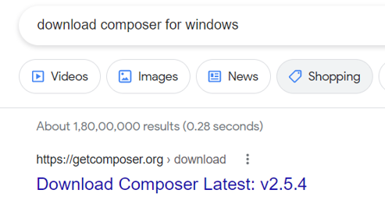

🡺 link -- https://getcomposer.org/download/

**🡪** [Composer-Setup.exe](https://getcomposer.org/Composer-Setup.exe)

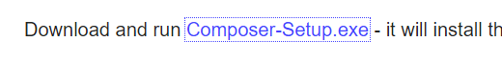

🡪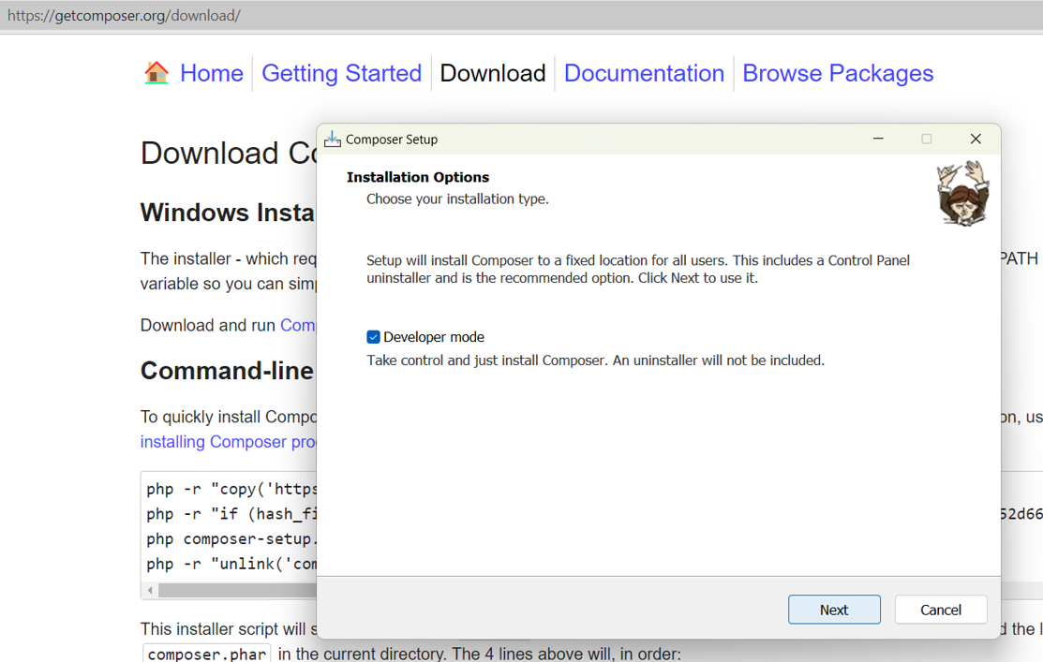

For checking –

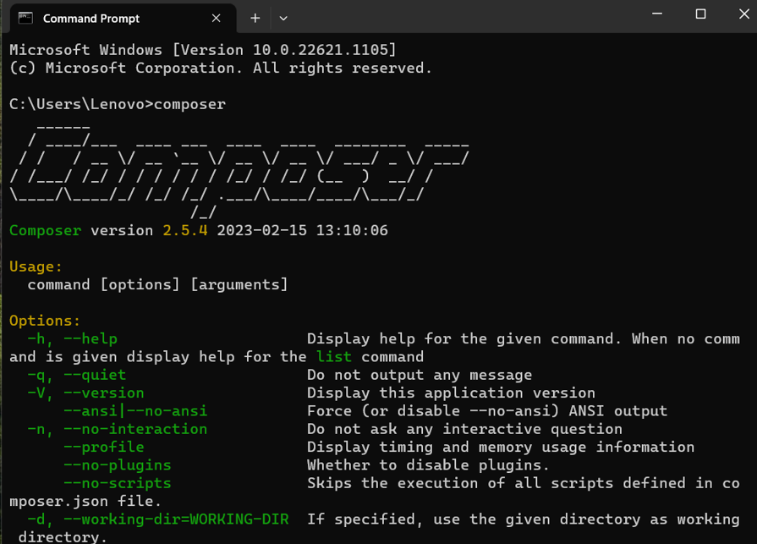

**Here when THAT image COMPOSER [----] is shown in cmd then Composer is downloaded.**

**Command to Create a project in Laravel**

* **Composer create-project laravel/laravel Project name**

**For running cmd:-**

**php artisan serve**

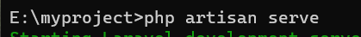

**c**

**2nd way to Download Composer –**

**By using cmd**

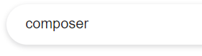

Copy and paste on Cmd – download then….

[installing Composer programmatically](https://getcomposer.org/doc/faqs/how-to-install-composer-programmatically.md).

**php -r "copy('https://getcomposer.org/installer', 'composer-setup.php');"**

**php -r "if (hash_file('sha384', 'composer-setup.php') === '55ce33d7678c5a611085589f1f3ddf8b3c52d662cd01d4ba75c0ee0459970c2200a51f492d557530c71c15d8dba01eae') { echo 'Installer verified'; } else { echo 'Installer corrupt'; unlink('composer-setup.php'); } echo PHP_EOL;"**

**php composer-setup.php**

**php -r "unlink('composer-setup.php')**

**For Example –**

**My first project:-**

**Composer create-project Laravel/Laravel myproject**

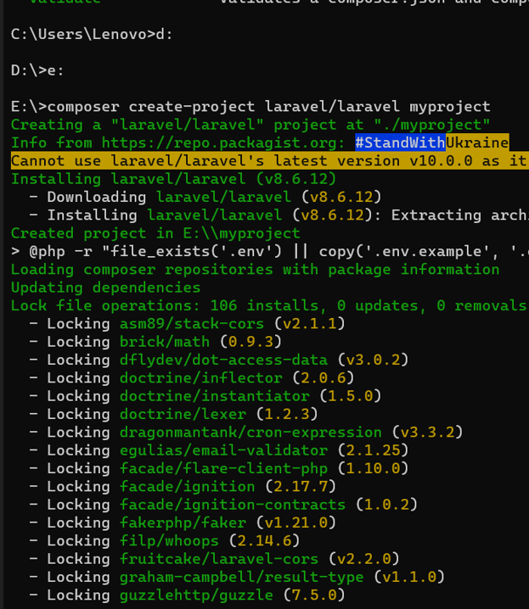

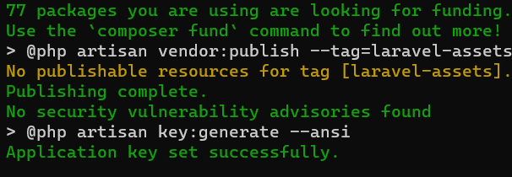

**Running :-**

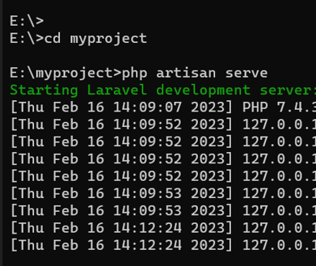

**Then check browser.**

**And type –**

* **Localhost:8000**

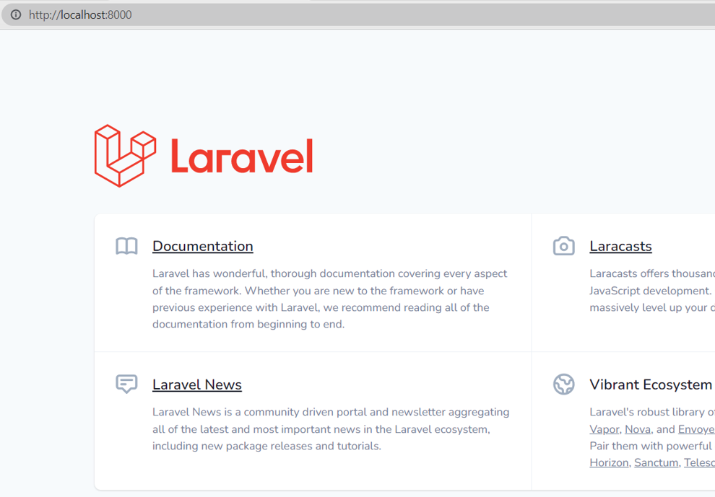

* **Resources**
* **View :-**

We work in views file, and in this (**home.blade.php**)

[ [home.blade.php](http://home.blade.php) 🡪 is a **Template file**]

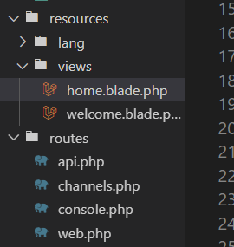

Isme bani file (abc.blade.php) me hum apna code likhte hai.

* **Public –** In this we add css,js files…

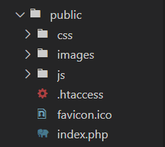

* **In routes (web.php)**

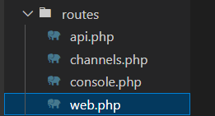

**In this file we add –**

Isme vo file add karte jo hmne bana ho or jise run karna hai.

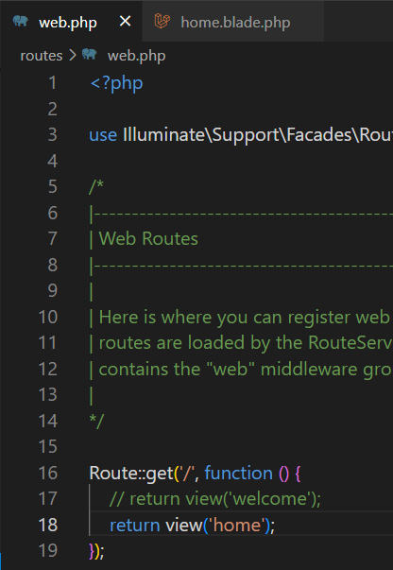

**In browser Run:- localhost:8000**

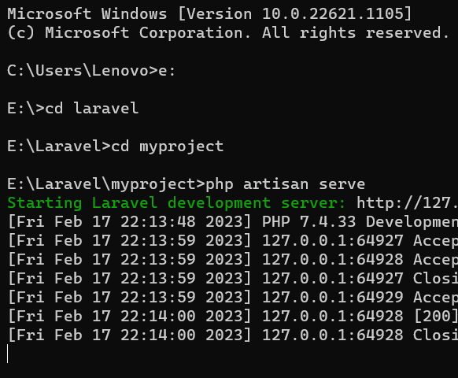

**Bootstrap:-**

1. Bootstrap css
2. Bootstrap js

**Laravel follows which pattern?**

Laravel is a PHP based web framework, if follows MVC (Model-View-Controller) pattern.

**Model – Model contain database part for web application.**

**View – View decides which web page should be Open on a particular request.**

**Controller – Controller Controls the functionalities of the web application.**

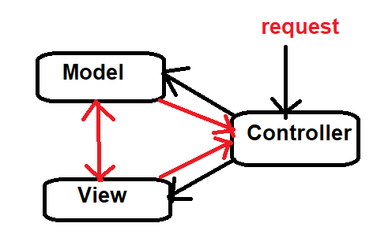

**How to create Controller –**

**php artisan make: controller EnquiryController**

**php artisan migrate**

**scope resolution operator**

 DB: :insert();

**parameter locator**

(?,?,?,?,?,?)

**csrf_token() 🡪 This token encrypt posted data.**

**@yield(‘content’) 🡪**

**Here we write the content .**

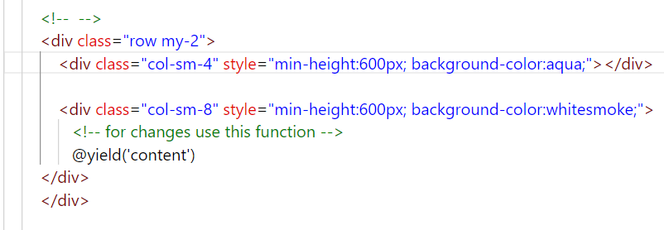

**For linking –**

**Project –**

**Step 1 –**

* **Create project –**

**Composer create-project larvael/laravel demo1**

* After creating we can see that –



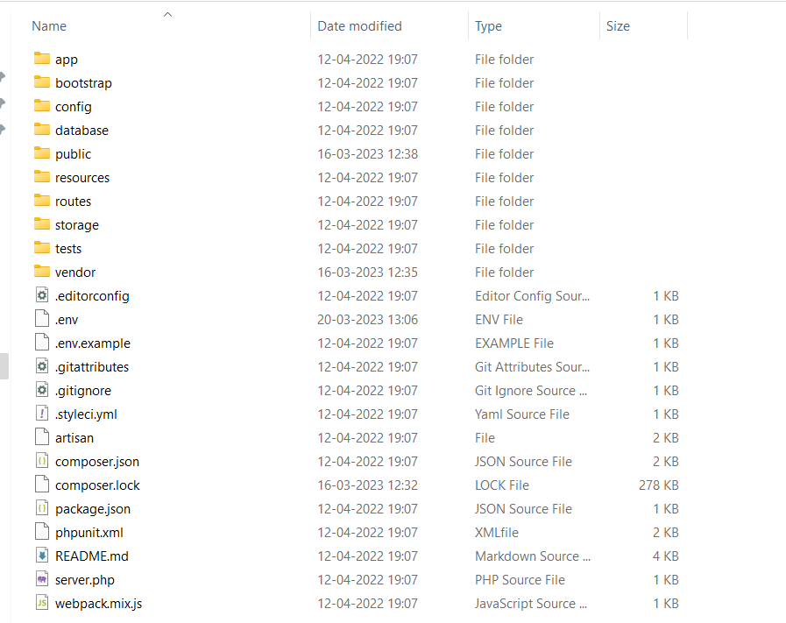

* **Run –**

**php artisan serve**

**Step 2 –**

* **For code go to folder –**

**Resource** 🡪 **view** 🡪 **yourfilename.blade.php**

**For example –**

**1**

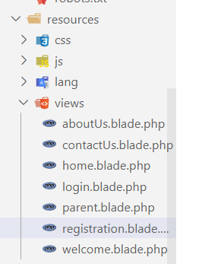

* **For add CSS and JS & Bootstrap files also –**

Go to the public folder make a CSS/JS folder then add CSS file

**Public 🡪 CSS 🡪 app.css**

**Public 🡪 JS 🡪 app.js/bootstrap.js**

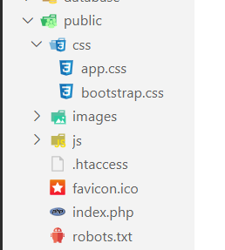

**For Adding Image –**

Go to public folder make a Image folder and add their images here

**Make Parent file –**

**That is a demo/parent file 🡪 this connect for all file.…**

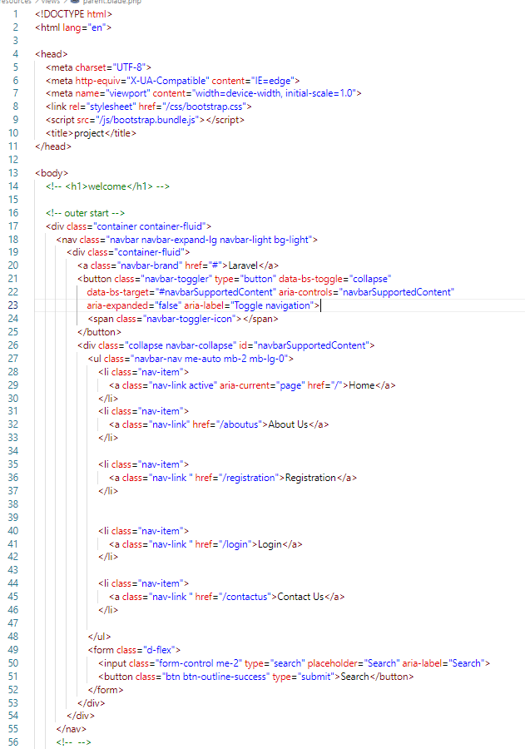

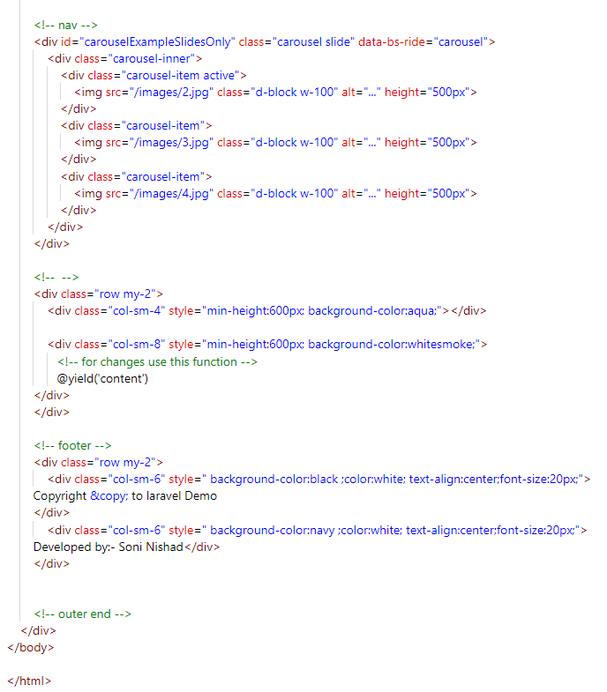

**_____________________________________________________________________**

**@yield(‘content’) 🡪 Here we write all content**

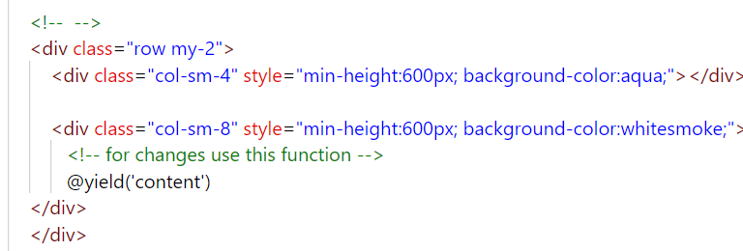

**href= “/”**

**href= “/aboutus”**

**href= “/registration” …..**

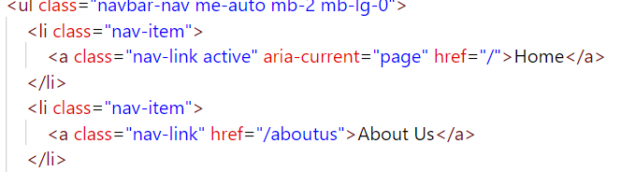

**Add –**

**@extends(‘parent’)**

**@section(‘content’)**

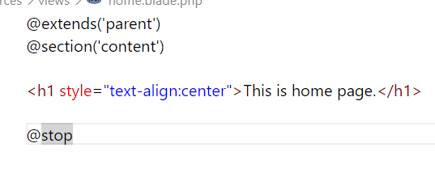

**@stop**

**Step 3 –**

For linking without linking this file (web.php) will not run so linking is must.

Add [ web.php ]

* **Routes 🡪 web.php**

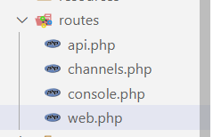

All files linked here ( web.php ) then run –

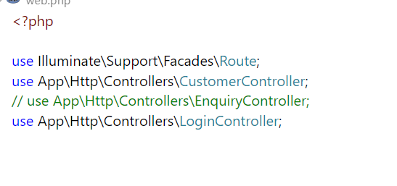

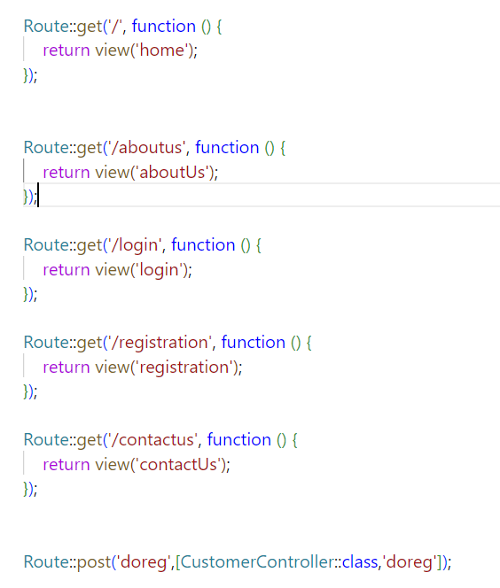

* **For Making Controller –**

**php artisan make:controller CustomerController**

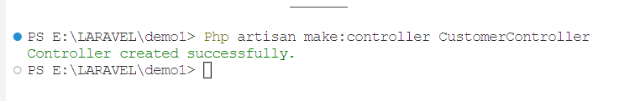

**App 🡪 Http 🡪 Controllers 🡪 filename.Controller.php**

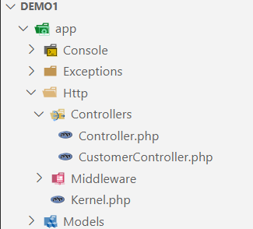

**🡺 This file code for connect the server/database and take input form user...**

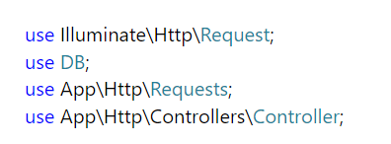

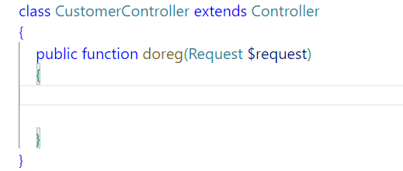

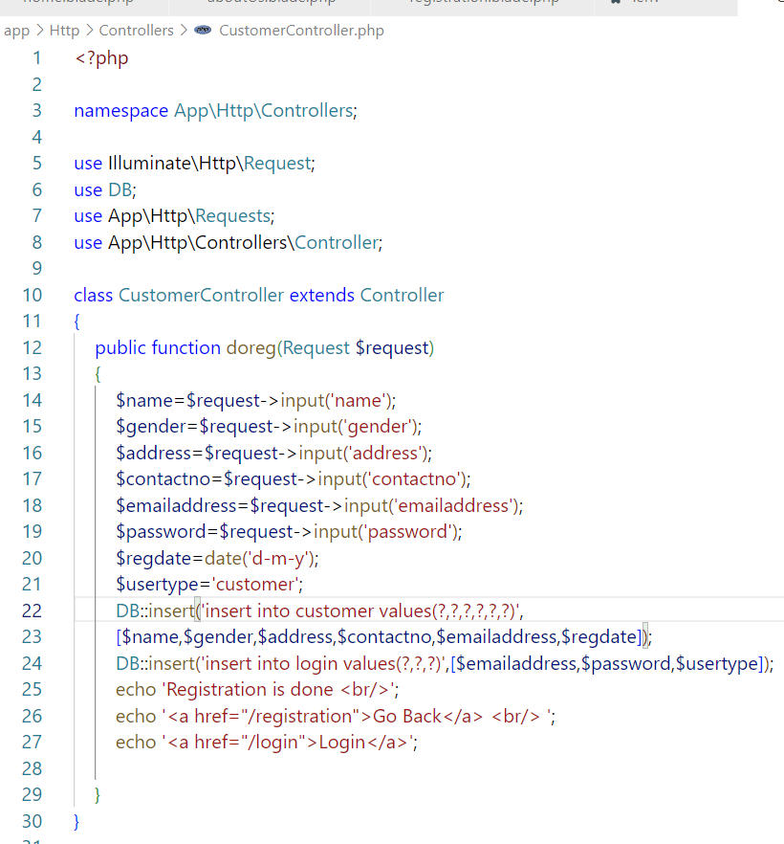

* **.env –**

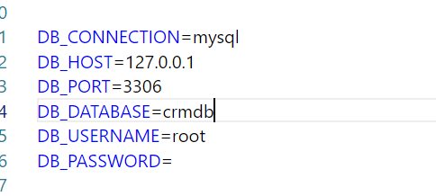

In this file we write Database Name

**For Ex – crmdb**

**After Controller create 🡪 web.php**

Adding all controller files in here …

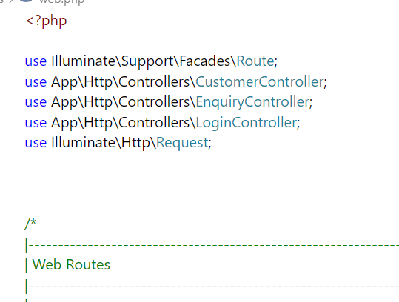

And last adding this in web.php –

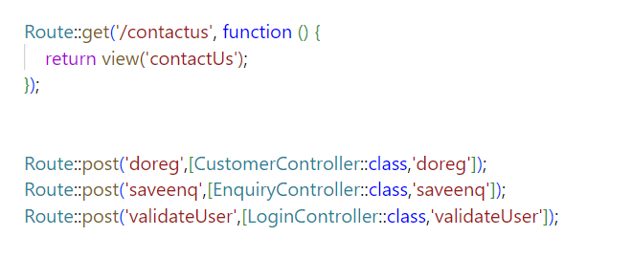

**🡺 doreg, saveenq** that all is redirect method of files eq **– post/get** 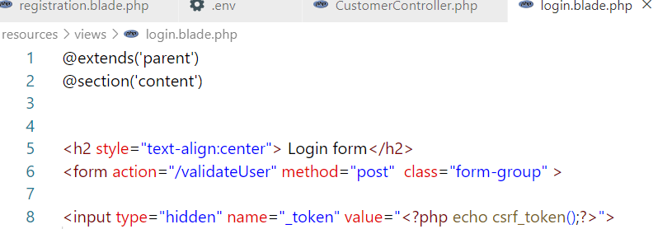

**🡺 Login.blade.php**

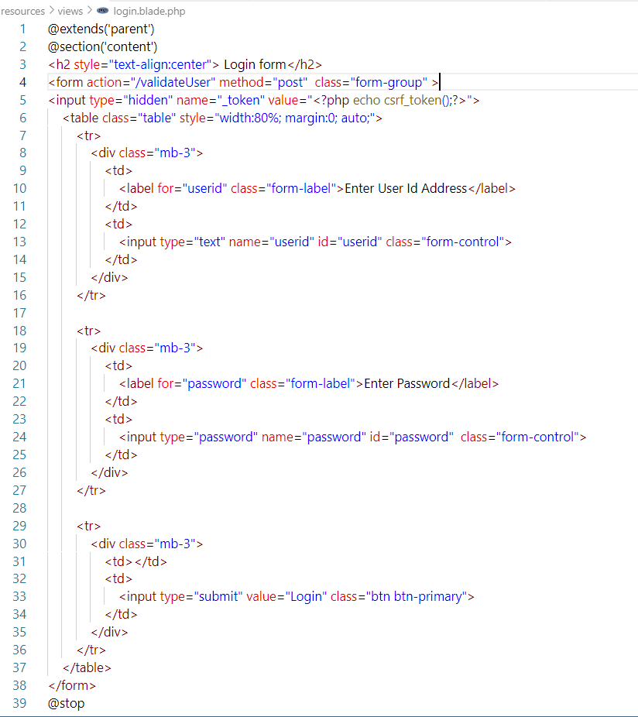

**For insert query –**

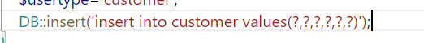

**?,?, -🡪 that is called a parameters**

**Create Components –**

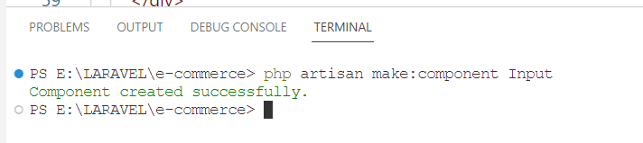

**App 🡪View 🡪components 🡪files**

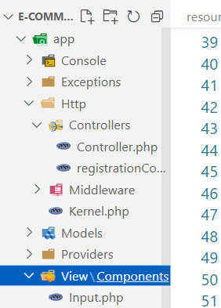

**Resources 🡪 view 🡪 component 🡪 input.blade.php**

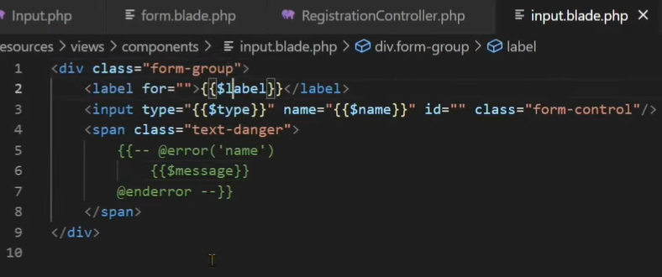

**🡪**

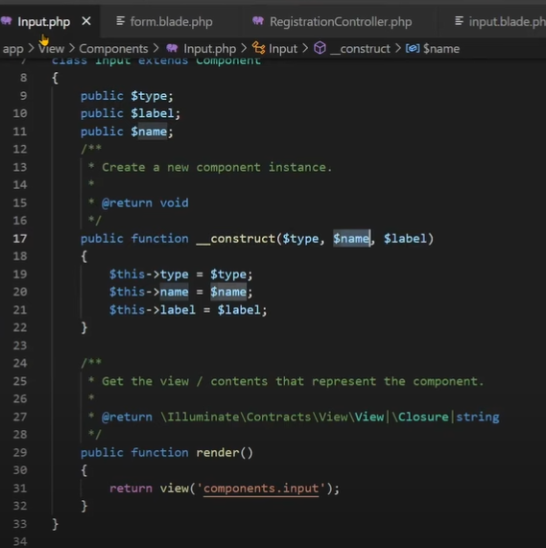

**🡪**

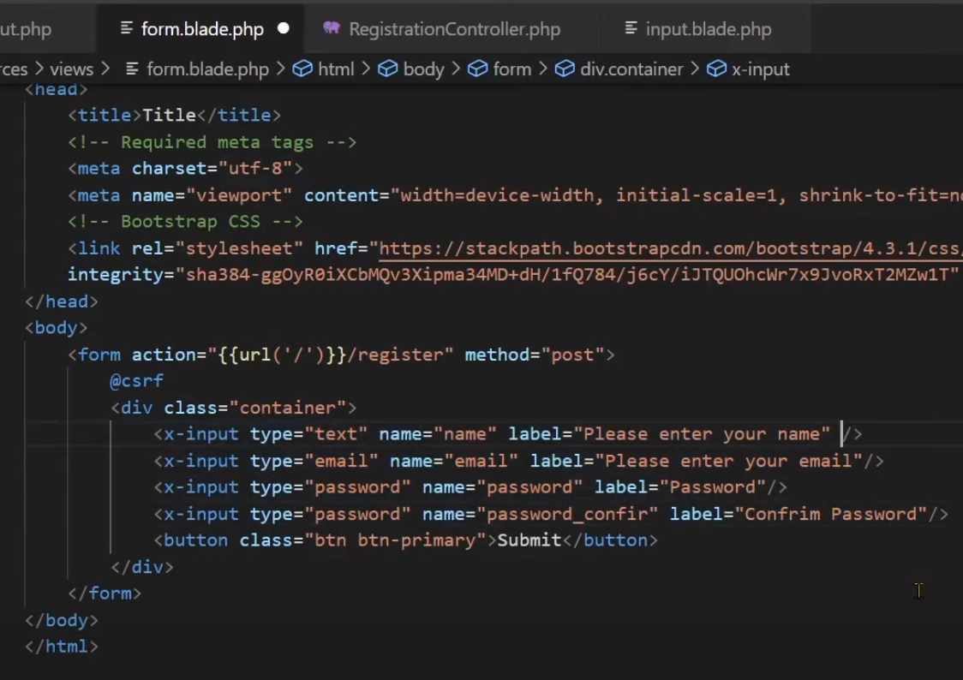

**Migration**

**For Creating Migration – php artisan make:migration tablename**

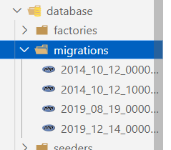

**Database Configration Migration – php artisan config:Cache**

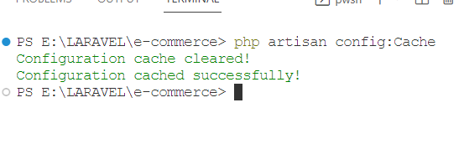

Database me table create karna …….

**Migrate - php artisan migrate or php artisan migrate-force**

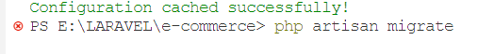

Laravel me migration ki help se tables create karte hai automatically.

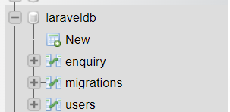

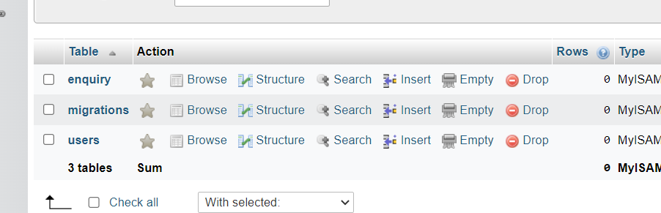

**Rollback (Bani hui table to delete karna ) – php artisan migrate:rollback**

**Refresh -- php artisan migrate:refresh**

**LARAVEL**

**What is Laravel?**

* PHP-based web framework. 🡨 help to make websites………
* Open-source PHP framework.
* Follows the **model-view-Controller (MVC)** architectural pattern.
* **Taylor Otwell** developed Laravel in July 2011.
* Most popular PHP frameworks.
* Works with the help of Artisan CLI.

**Steps to follow –**

1. **Installation of PHP Local Server (XAMPP).**
2. **Installation of Composer**
3. **Installation of Laravel Globally**
4. **Creating a new project**
5. **Installation of a code editor (VS Code).**

**____________________________________________________________**

1. **Installation of Composer**

<https://getcomposer.org/download/>

**check 🡪 composer**

1. **Install Laravel Globally**

**laravel.com**

Installation 🡪 install via composer

1. composer global require Laravel/installer
2. Laravel 🡪 check
3. **Create Project**

**laravel new project-name**

**cd 🡪 change drive**

**cls 🡪 clear screen**

**Running–**

**php artisan serve**

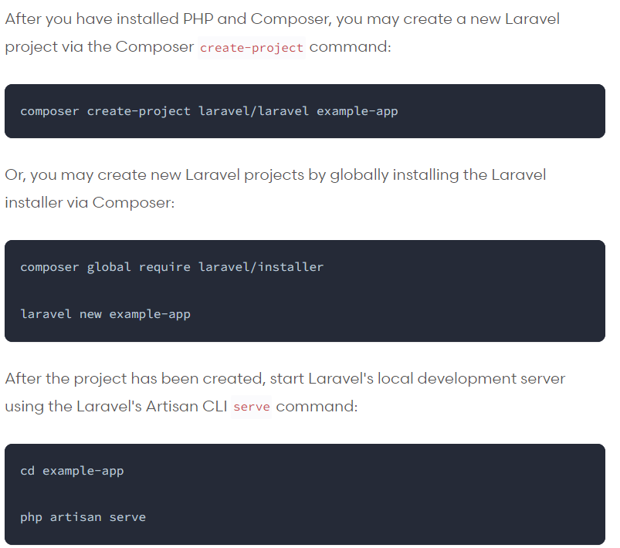

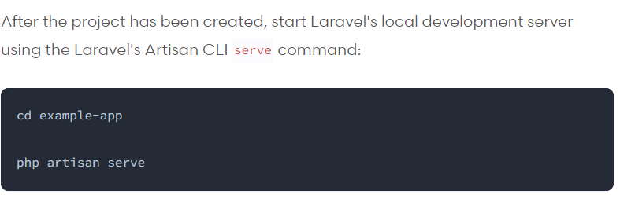

**Directory Stucture**

1. **App**

**Console**

Kernal.php 🡪 for creating used command

**Exception**

Handler.php 🡪 for creating custom handlers 🡺 run time

error/exception ko handle krne ke liye.

**Http**

Controllers

Controller.php 🡪 baseController ko extend karta hai.

Middleware

Authenticate.php 🡪 |

EncryptCool.php 🡪 |🡪 All are work as a Garde

…………………….. 🡪 |

**Kernel.php** 🡺 ye app ki kernal.php hai, yaha pr middleware ki

confication hota hai .

Custom middleware ki confication yaha karte hai.

**Models**

User.php 🡪 database me user naam ki table hai usko represent

karta hai.

**Provides**

AppServicesProviders 🡪 providers service provide karte hai,

App me jitne bhi external or internal Packages use

honge un sabhi ke providers yaha mil jayenge.

1. **Bootstrap**

Kisi bhi application ko turant start karna… **[ speedup]**

**Cache🡪**Infuture cache store karegi bcz speed bni rhe performnce shi rhe.

1. **Config**

app.php

mail.php 🡺 for use for confication

auth.php

1. **Database**

**Migrations 🡪 That is handled the table of database.**

**Factories 🡪** for creating fake data / testing mode me fake data

create krne me help krta hai.

**Seeders**

1. **Public**

htaccess.ico

index.php 🡪 This is load first file.

robots.php 🡪 Rest all are SEO files

1. **Resources**

**View**

**Welcome.blade.php** 🡪 Blade is a template engine, Laravel

provide karta hai.

**CSS**

**JS**

1. **Routes**

**api.php 🡪** ye API ke routes handle karti hai

**web.php 🡪** user ko koi page open karane ka kaam krta hai.

Ye web ke routes handle karti hai.

1. **Services**

🡪 That is handle the services of our websites.

1. **Storage**

🡪That is handle the storage of our websites.

1. **Tests**

🡪 Test cases are written here

1. **vendor**

🡪 This provides all package files.

1. **env**

🡪 This setup of the environment/connection or other details

1. **Composer.json**

🡪 this is stored in the package information.

1. **Server.php**

**🡪** app ko execute karne me help karti hai / kis directory me run Karna.

1. **Readme** 🡪 This is an optional file.

**🡺 PROJECT**

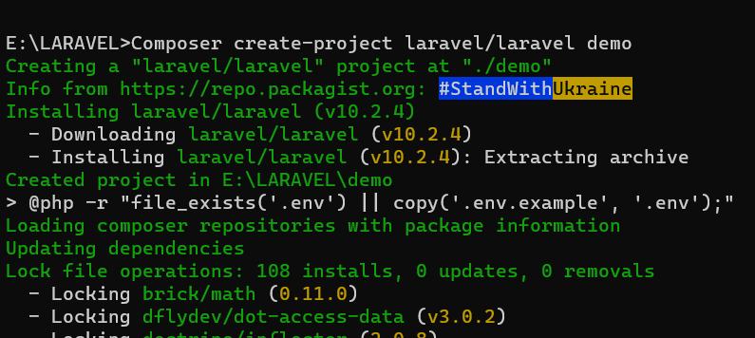

**What is Blade Template?**

* Blade is a templating engine in a Lravel framework.

[ Jab hum data ko display kara rhe ho browser par to, jo hamara view vala

part hota hai usko handle karane ke liye “B LADE” ka use karte hai.]

* Blade templating engine provides its own structure such as conditional statements and loops.
* To create a view file and save it with a **.blade.php** extension instead of **.php** extension.

**Example –**

***Displaying Data***

**Core PHP Syntax: Blade Template Syntax:**

<?php **{{ $name }}**

echo $name;  **{!! $name !!}**

?>

**Blade Template—**

**{{ $name }} 🡺 for simple Echo ( Html decode nahi karta.)**

**{!! $name !!} 🡺 For ( html ko decode karta hai )**

**PROJECT**

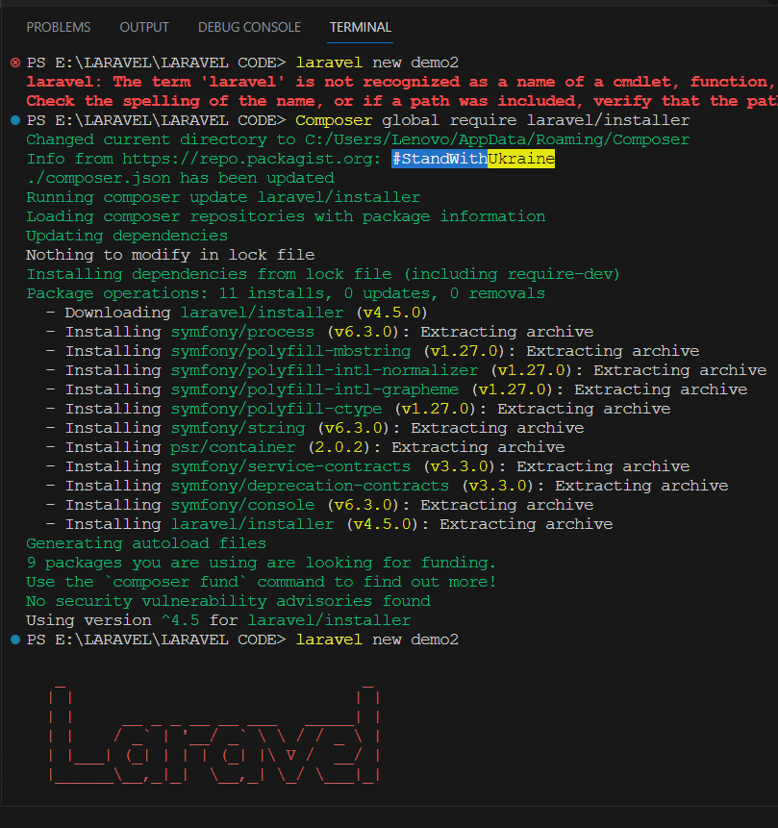

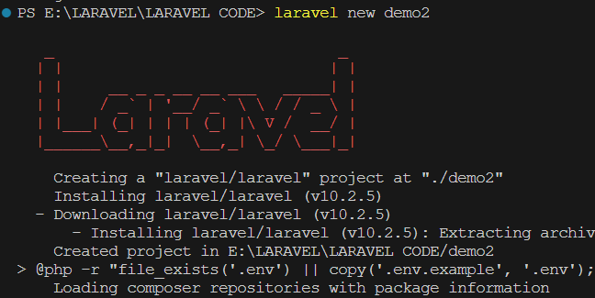

**Other Blade Directives**

**For Comments: {{ --Comment goes here --}}**

**For including: @include**

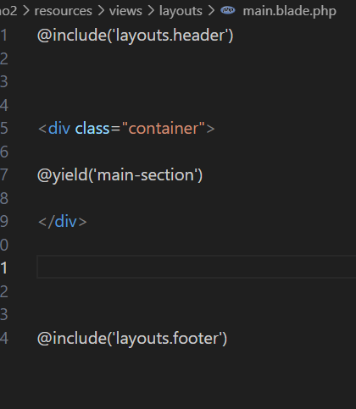

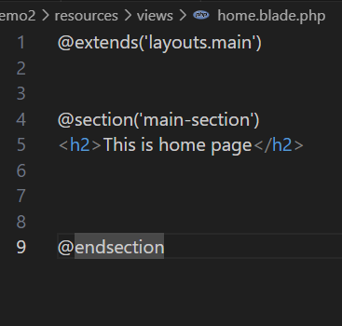

**Layout Blade Directives**

🡪 To render the complete stack content, pass the name of the stack to the

**@stack** directive:

**🡪 @push and @endpush** is used to push data into the stack.

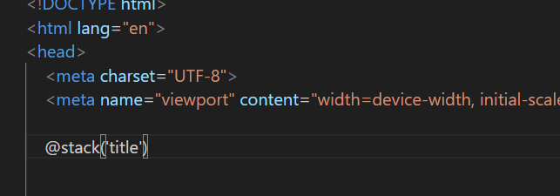

🡪Value send…

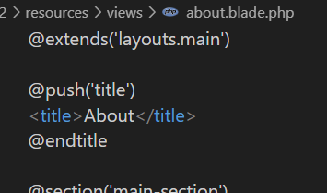

🡪OUTPUT

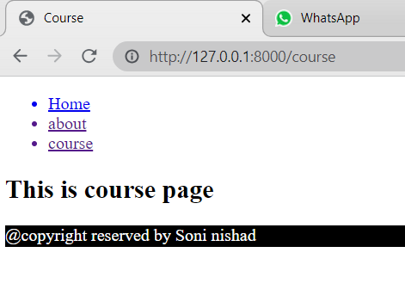

**Controller**

**What is Controller?**

* Controller are class-based PHP files.
* Controllers can group related request handling logic into a single class.
* Types of Controller

Basic Controllers

Single Action Controllers

Resource Controllers 🡺 crud operation predefined function makes

**Command to make Controller**

1. **Basic Controller:**

**php artisan make:controller ControllerName**

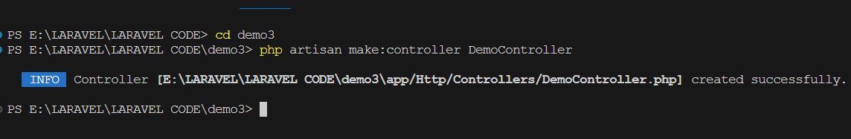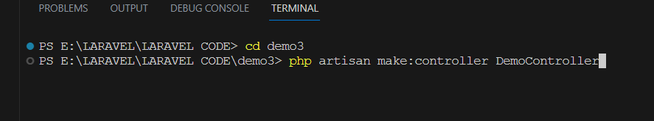

**🡪 Output [ File ]**

**App 🡪 http 🡪Controllers 🡪** democontroller

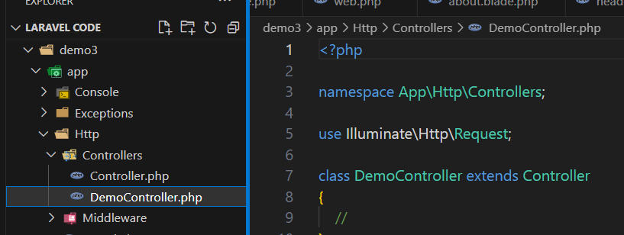

**2ND WAY TO ROUTING USING Controller –**

**DemoController.php**

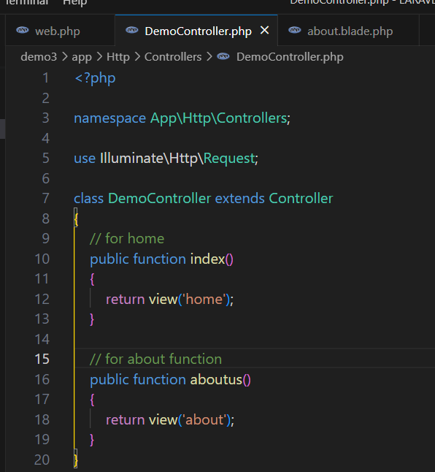

**Web.php**

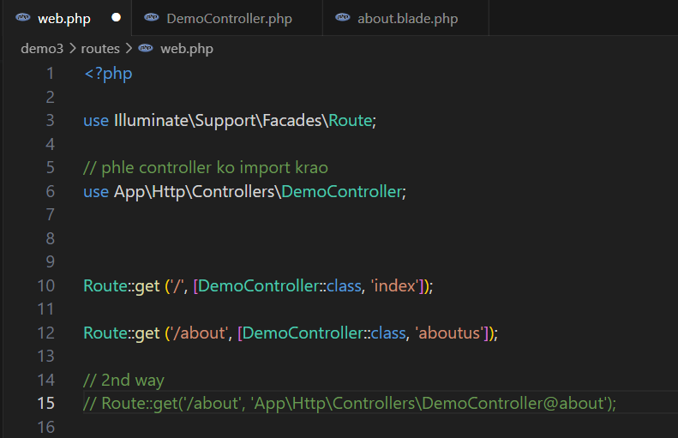

**Output –**

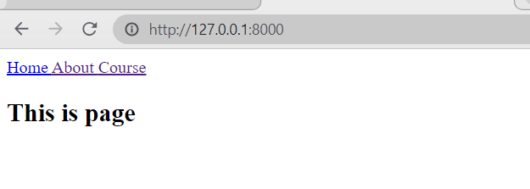

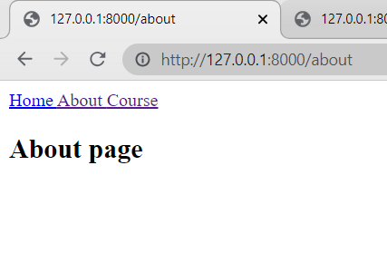

1. **Single Action Controller**— Sirf single function ko show krata hai.

**php artisan make:controller ControllerName** **--invokable**

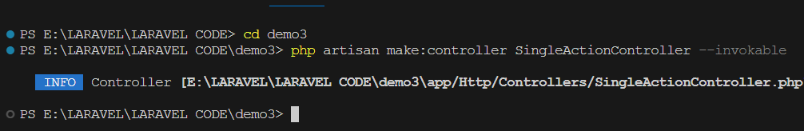

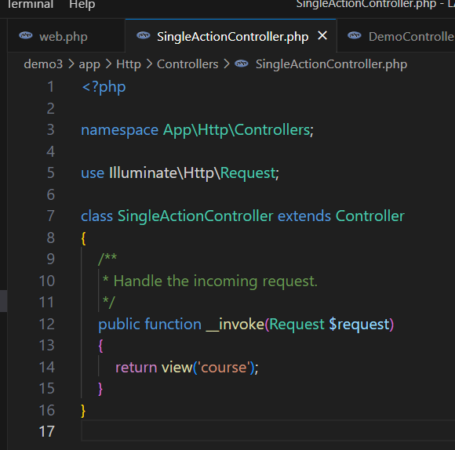

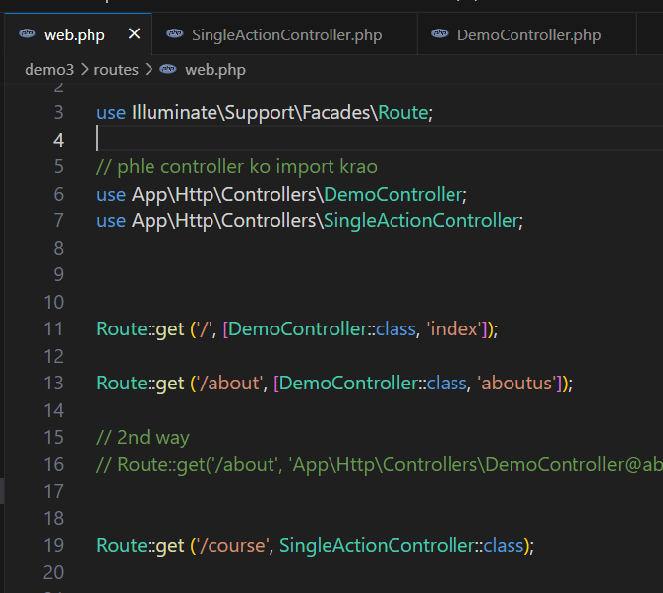

1. **Resource Controller –** Resourcecontroller me function change nahi kar sakte hai.

**php artisan make:controller ControllerName** **--resource**

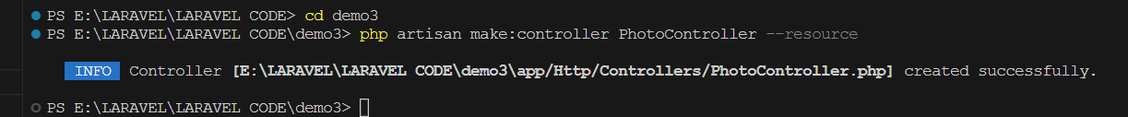

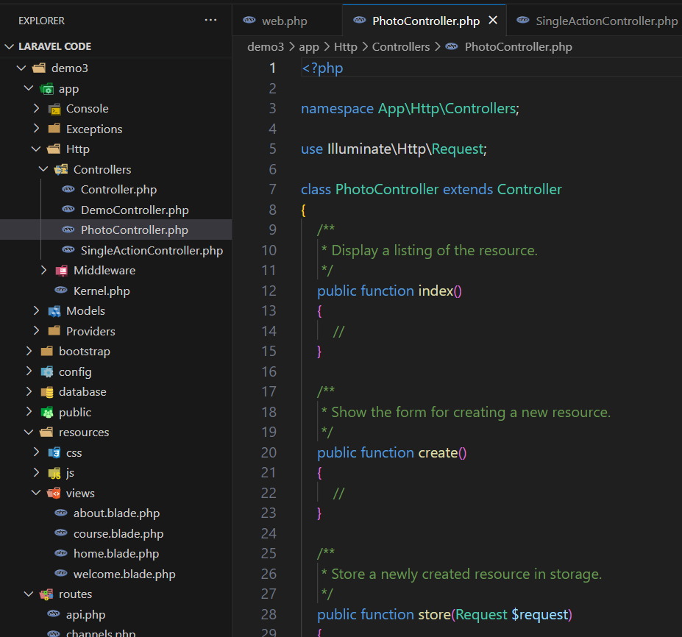

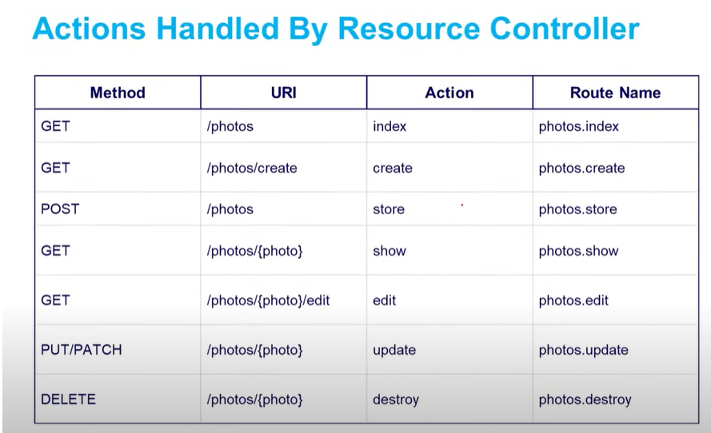

Working –

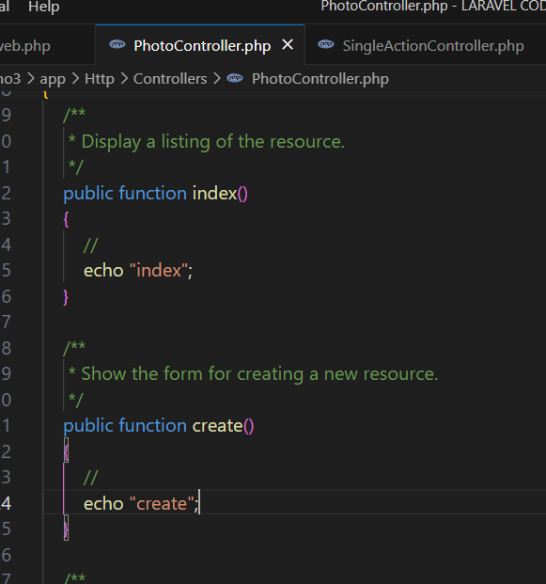

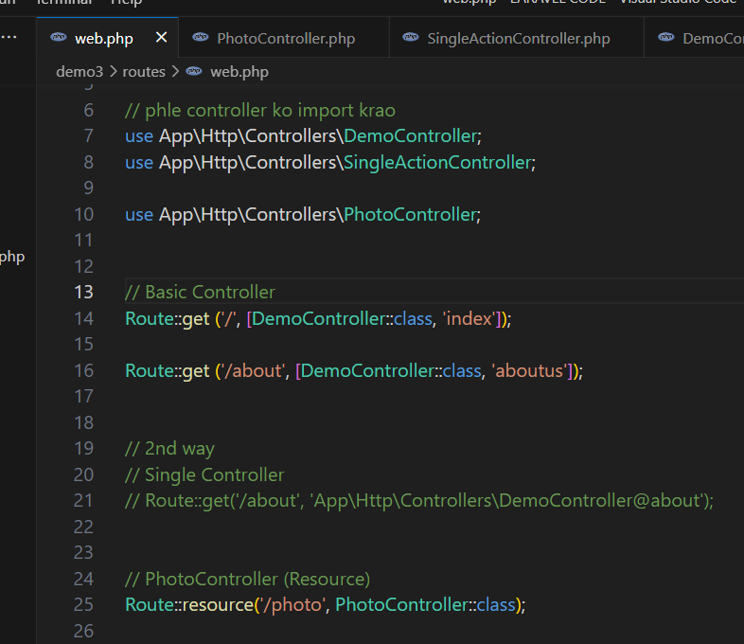

🡪http://127.0.0.1:8000**/photo**

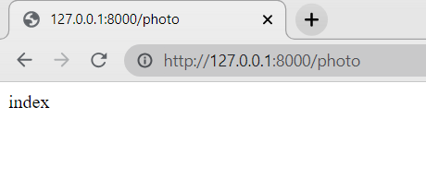

🡪 http://127.0.0.1:8000/**photo /create**

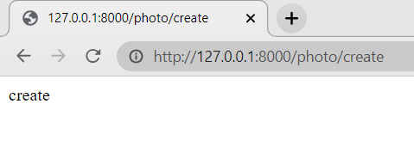

**FORM –**

Action=**”{{url(‘/’)}}/...”** 🡪 this is a base URL

{{url('/')}}

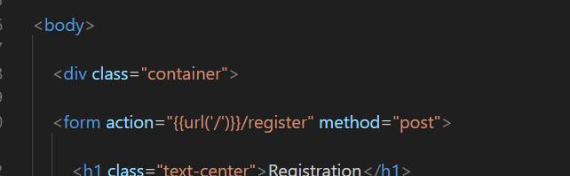

**@csrf 🡪** token

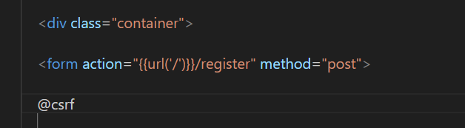

Form –

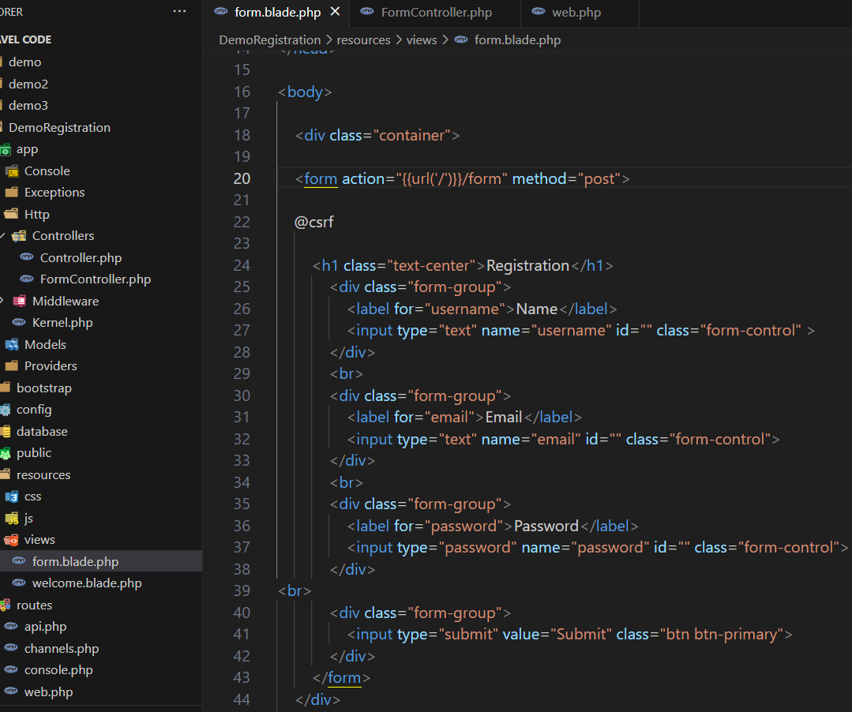

**FormController –**

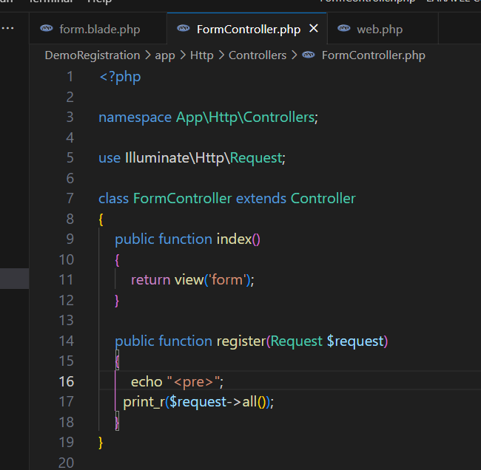

**Web.php –**

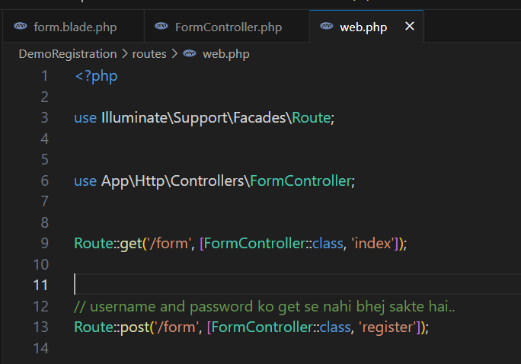

**Output –**

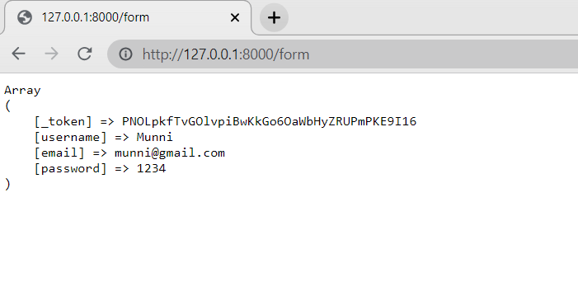

**FORM Validation using LARAVEL**

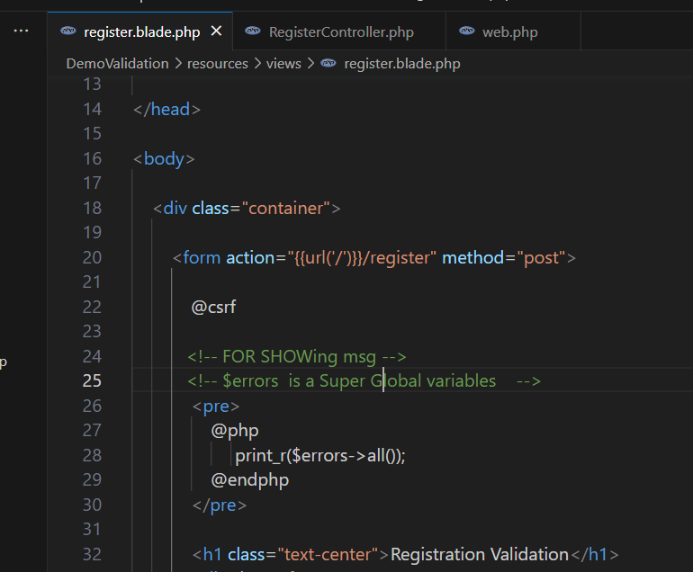

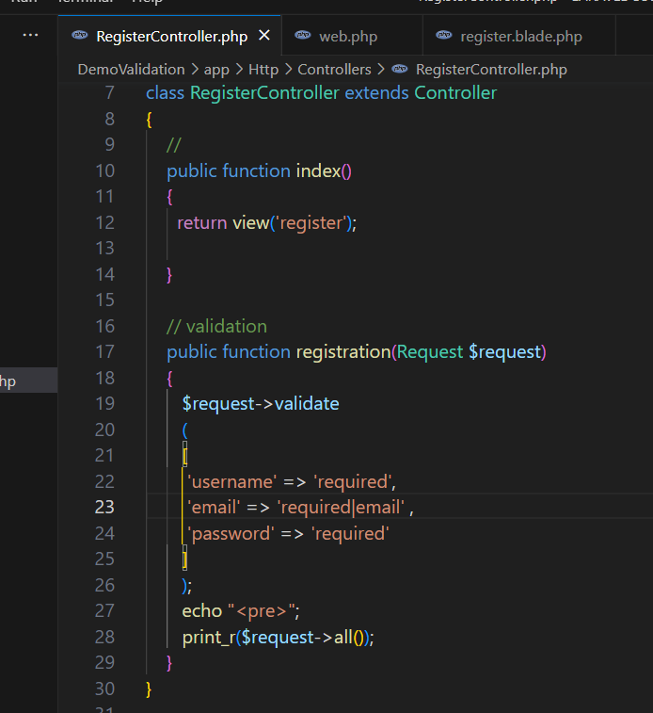

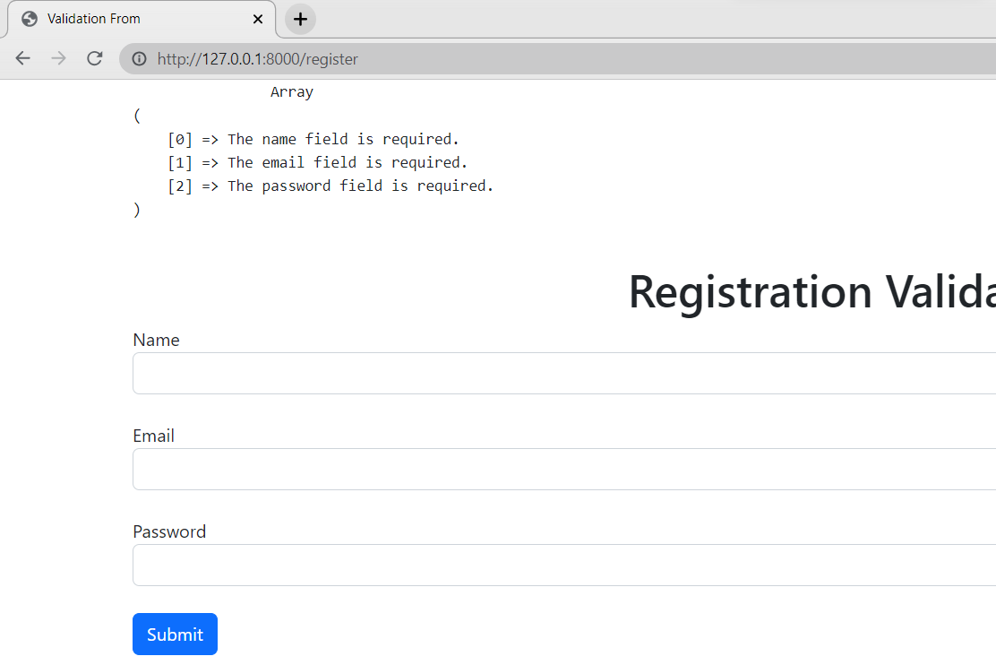

* When we fill correct data

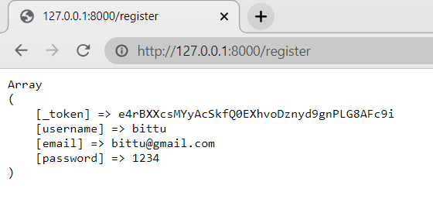

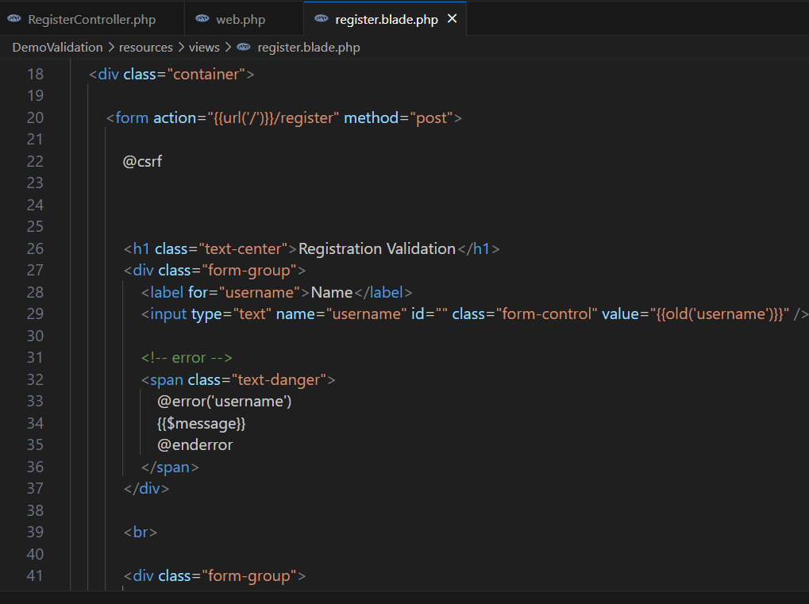

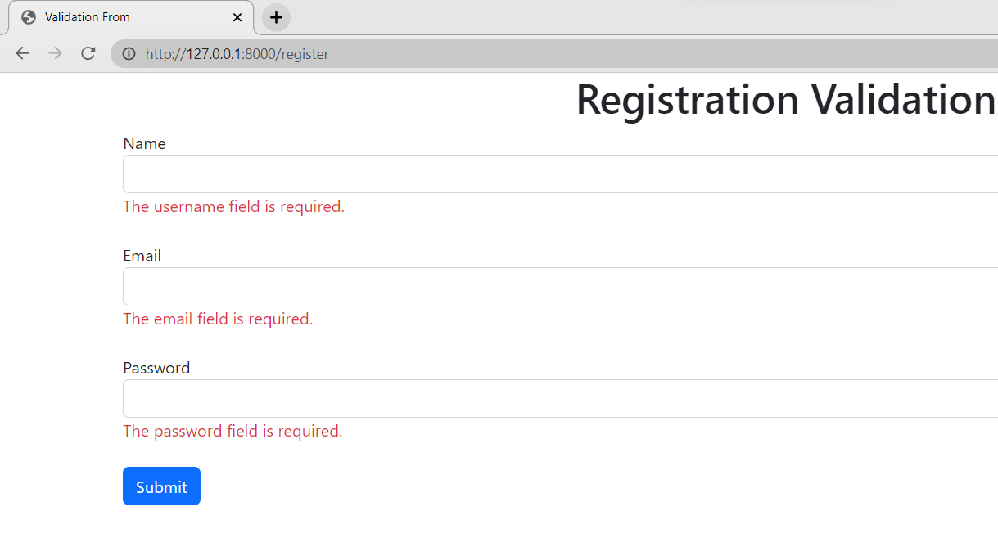

**COMPONENTS in Laravel**

**php artisan make:component ComponentName**

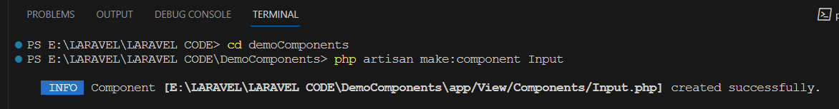

**Files make –**

* **App/View/Components/**component name
* **Resources/View/Components/**component name
* **App/View/Components/**component name

This is a class based component

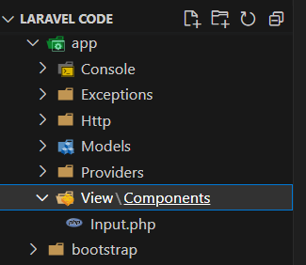

* **Resources/View/Components/**component name

This is a blade file.

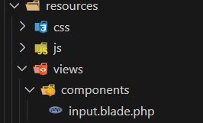

**🡺**Component meants we can also say that recalling

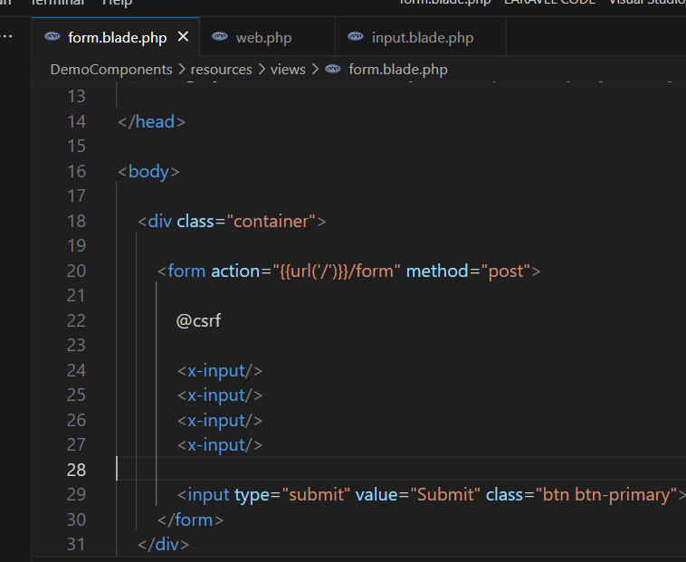

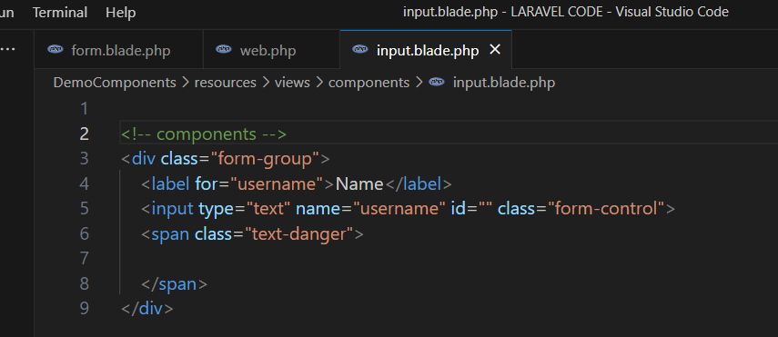

**🡺form.blade.php**

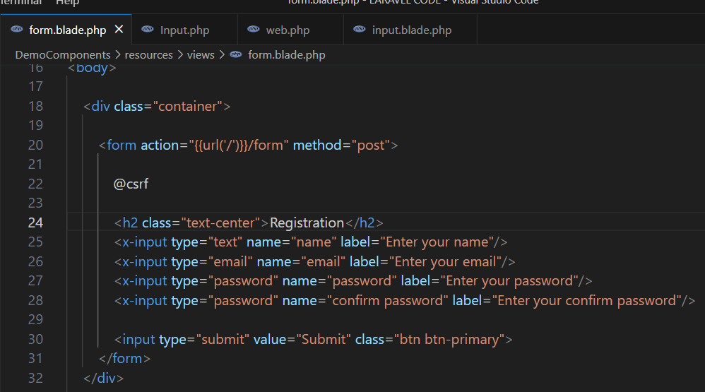

**🡺App –** input class redirect

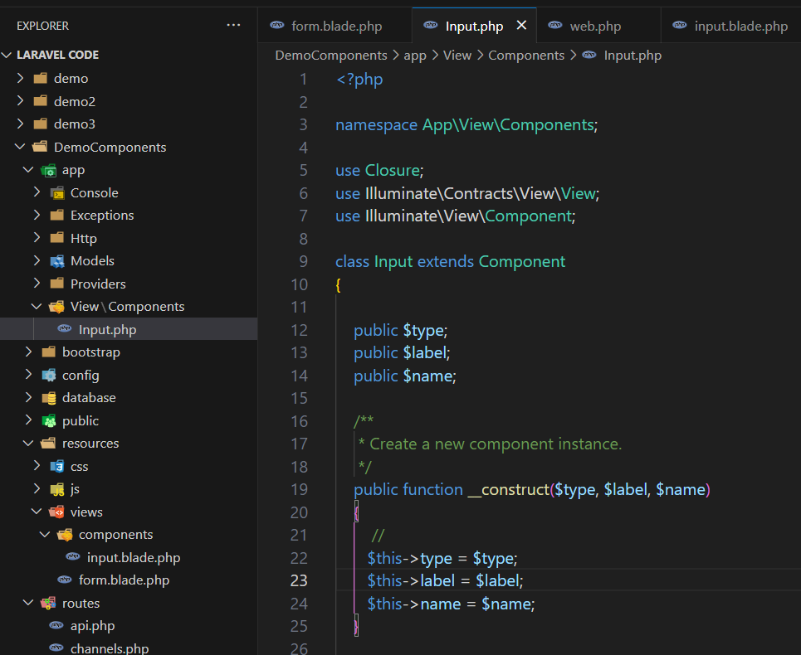

**🡺 Resources –** *input.blade.php* **–>** All changes are here

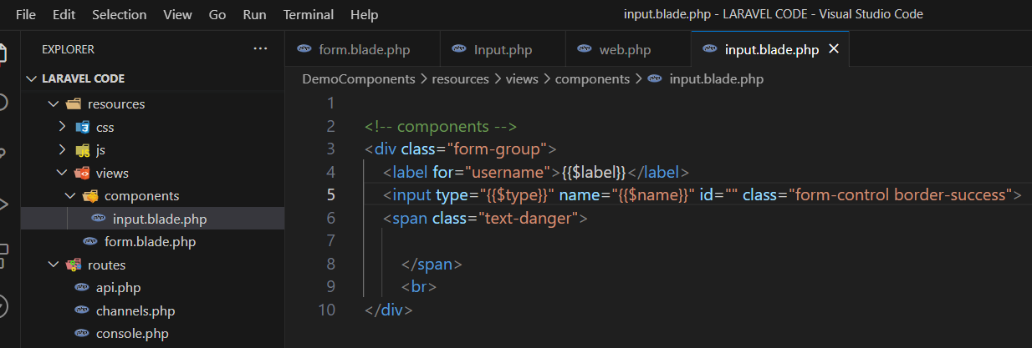

🡺OUTPUT

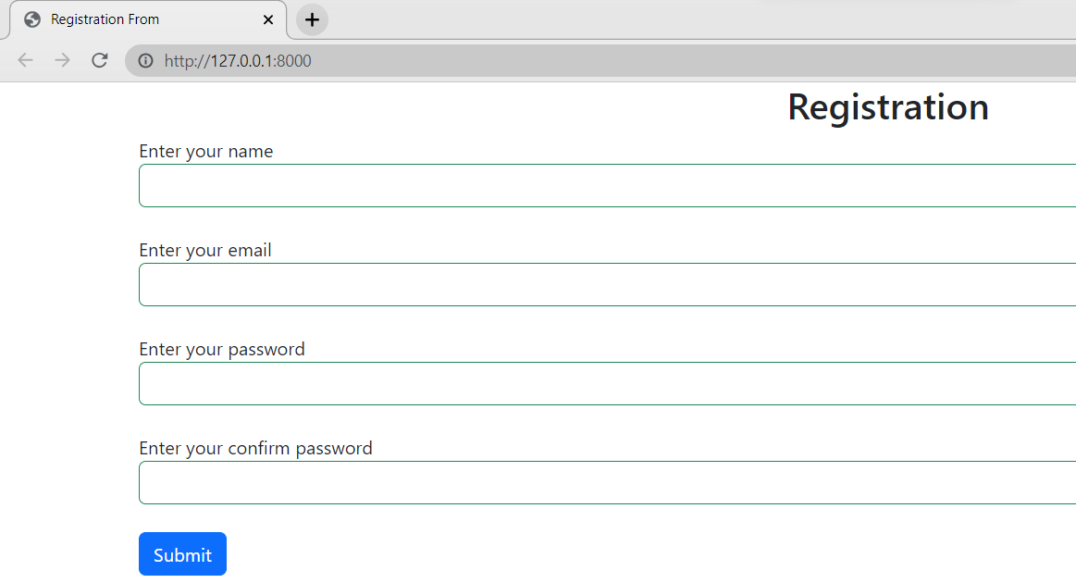

**MIGRATION**

When we use migration first time.

**php artisan config:Cache**

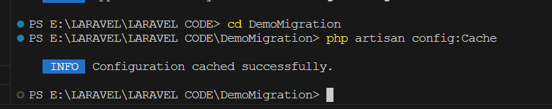

🡺

**php artisan migrate**

* Make database

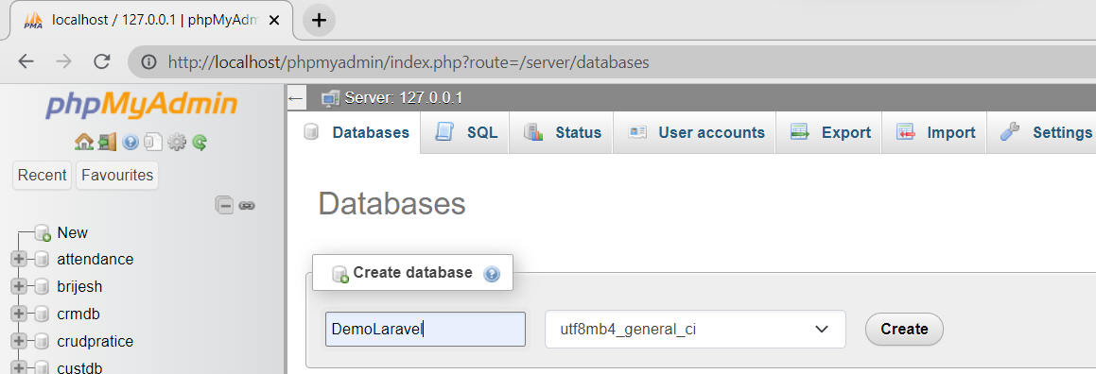

* .env

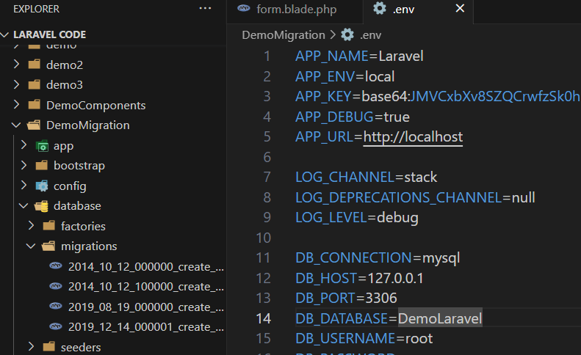

* Commands

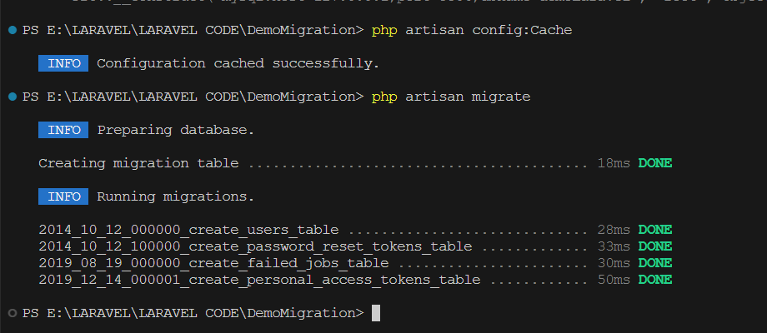

* php artisan migrate
* Database

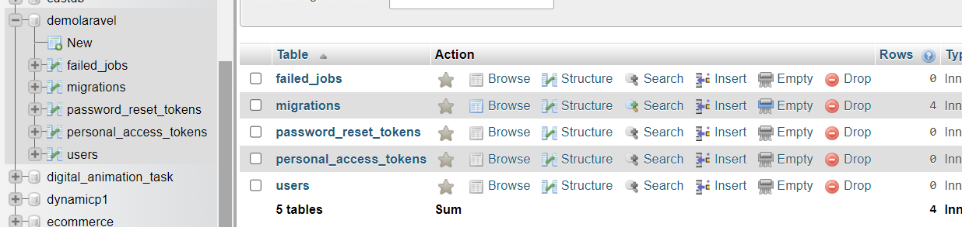

**How to Create table using Migration** in Laravel

**Migration Commands**

🡪 **php artisan make:migration create_table_name_table**

**🡪 php artisan migrate or php artisan migrate -force [ ]**

🡪 php artisane migrate:rollback [ For **delete the table** in the database]

🡪 php artisan migrate:refresh

**FOR Creating Table in DATABASE:-**

**php artisan make:migration create_table_name_table**

**php artisan migrate**



**Files –**

**Database/migrations/…**

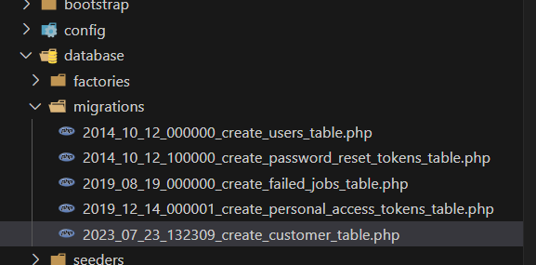

**🡪Queries**

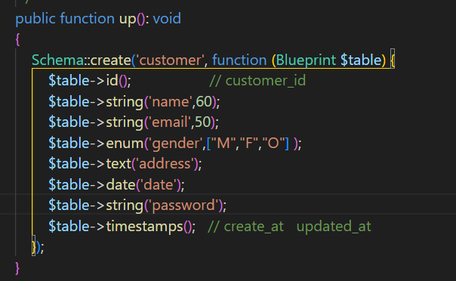

**🡺**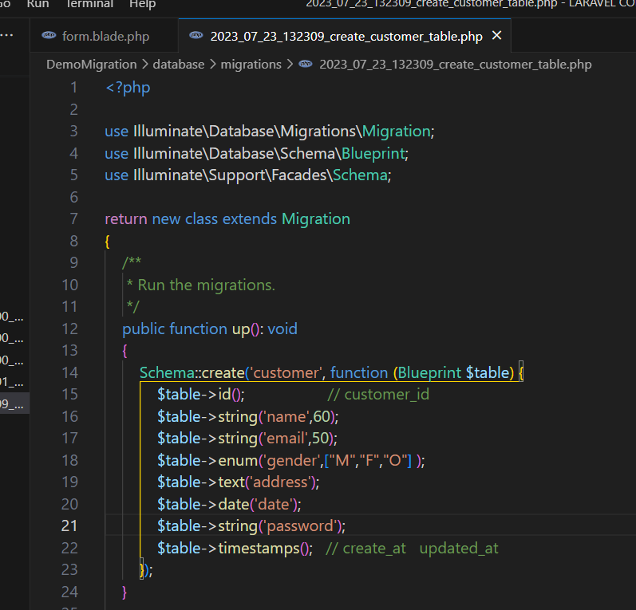

🡺 database 

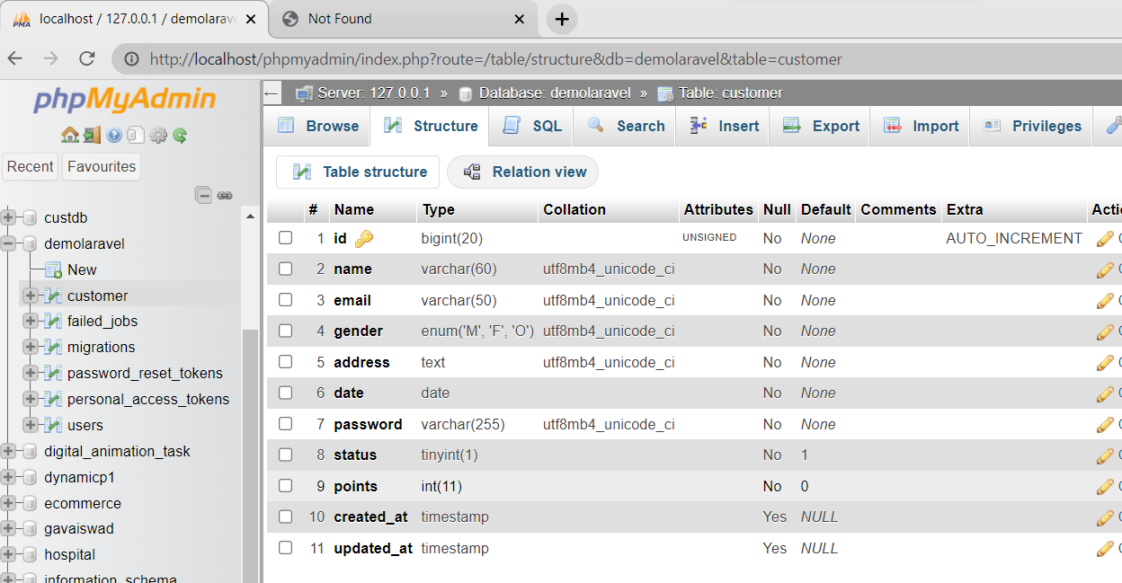

**🡪 php artisane migrate:rollback** – For delete database table

Here Customer table is deleted

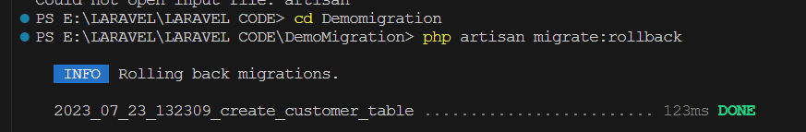

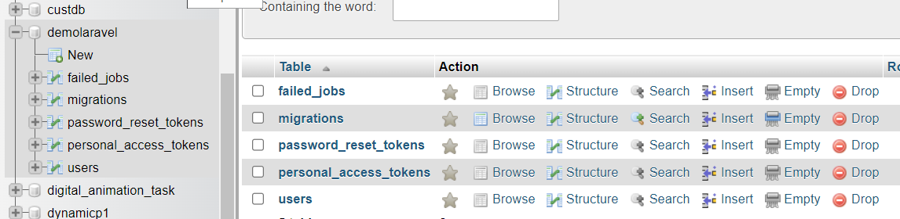

**🡪 php artisane migrate:refresh** –

After refreshing, All table removes and then refresh migrate [ also fresh make it ]

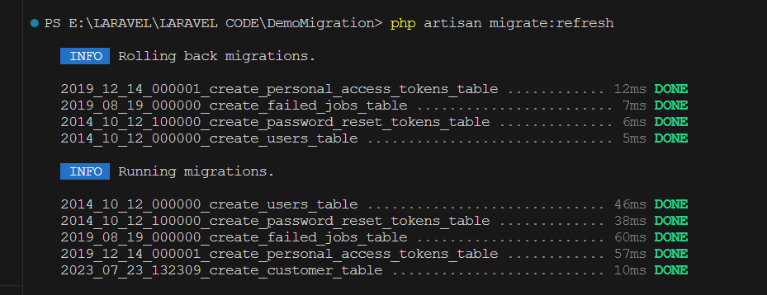

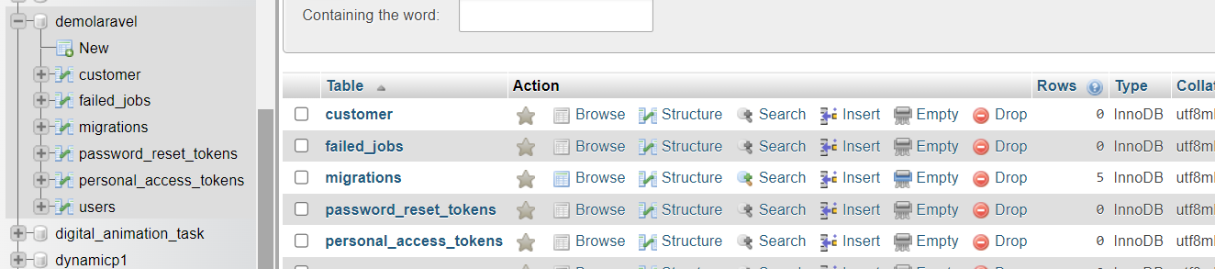

**For adding new Column in a table** –

**php artisan make:migration add_columns_to_Databasename_table**

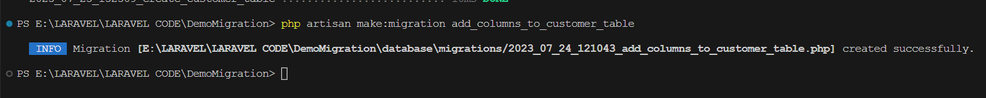

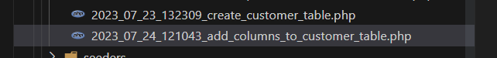

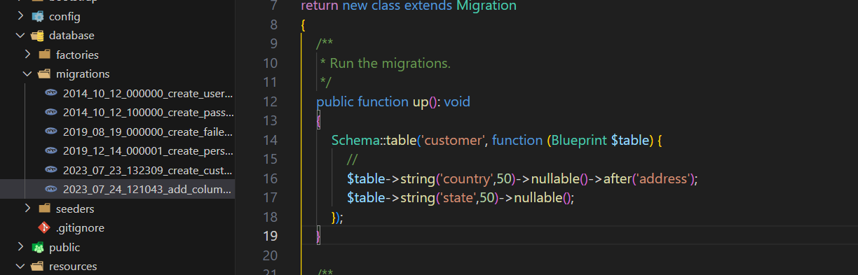

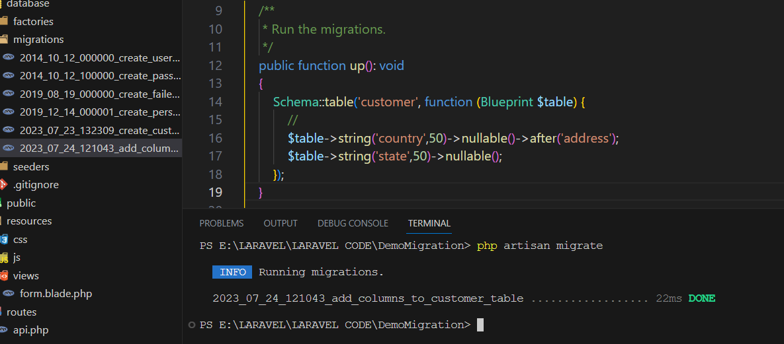



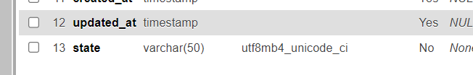

**MODEL**

* Models are class-based php files.
* Laravel includes Eloquent, an Object-relational mapper **(ORM – Object Relational Mapper)** that makes it enjoyable to interact with your database.
* Each database table has a corresponding “Model” that is used to interact with that table.

**Command to make MODEL**

**Only Model –**

**php artisan make:model <ModelName>**

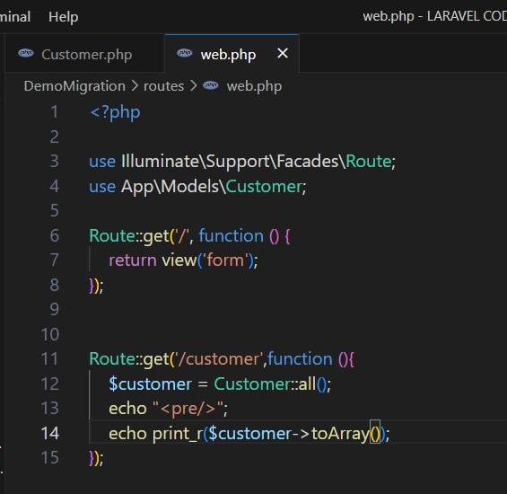

**🡪Output**

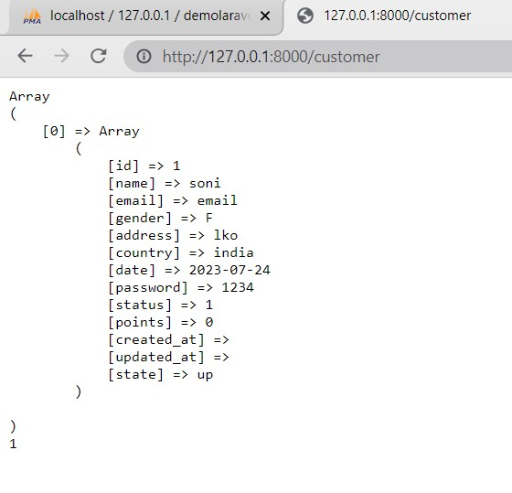

**When Model and Migration make both** –

**php artisan make:model TableName --migration**

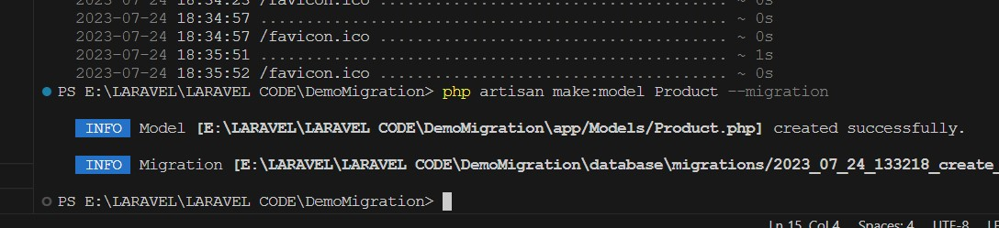

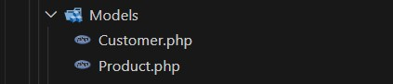

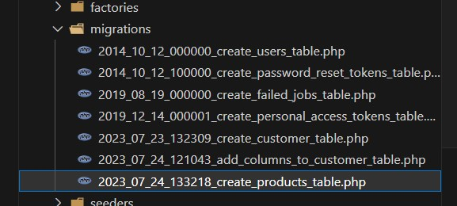

**LARAVEL**

🡪 download composer

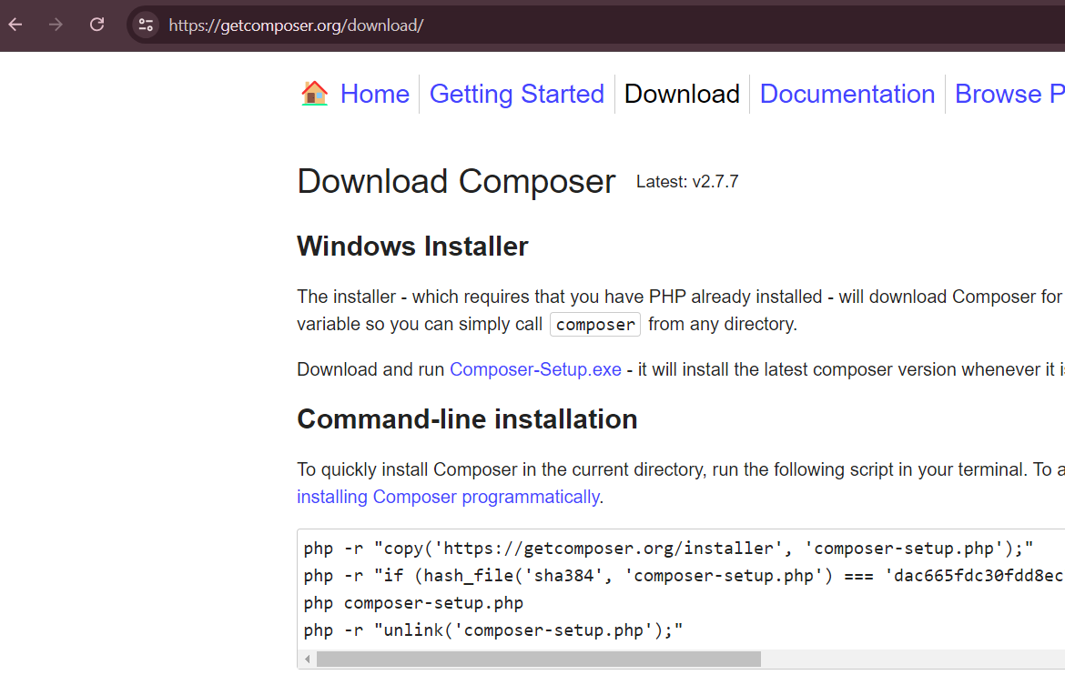

## 🡪Command-line installation

php -r "copy('https://getcomposer.org/installer', 'composer-setup.php');"

php -r "if (hash_file('sha384', 'composer-setup.php') === 'dac665fdc30fdd8ec78b38b9800061b4150413ff2e3b6f88543c636f7cd84f6db9189d43a81e5503cda447da73c7e5b6') { echo 'Installer verified'; } else { echo 'Installer corrupt'; unlink('composer-setup.php'); } echo PHP_EOL;"

php composer-setup.php

Laravel Download –

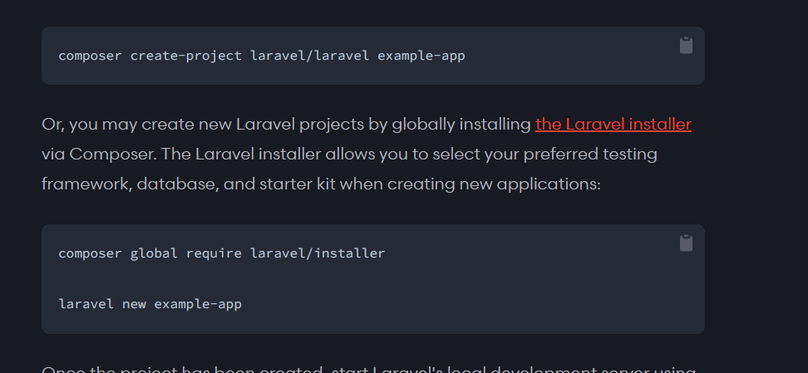

**Composer create-project Laravel/Laravel projectName**

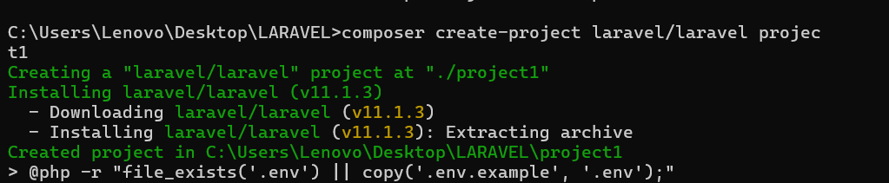

Run Laravel –

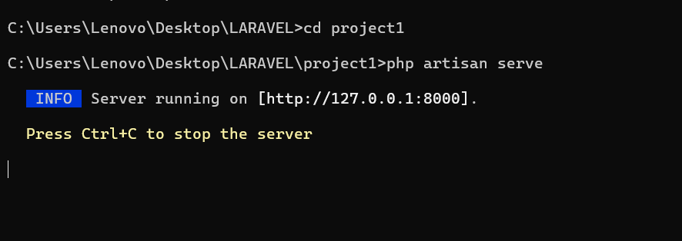

View –

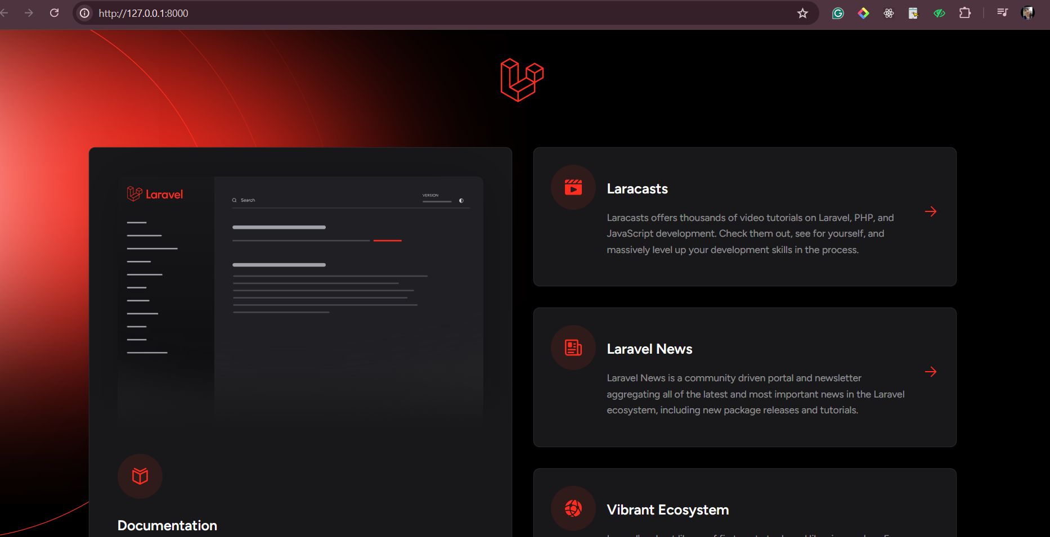

Resources 🡪 view folder

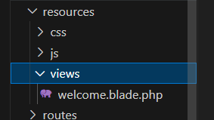

Database connection –

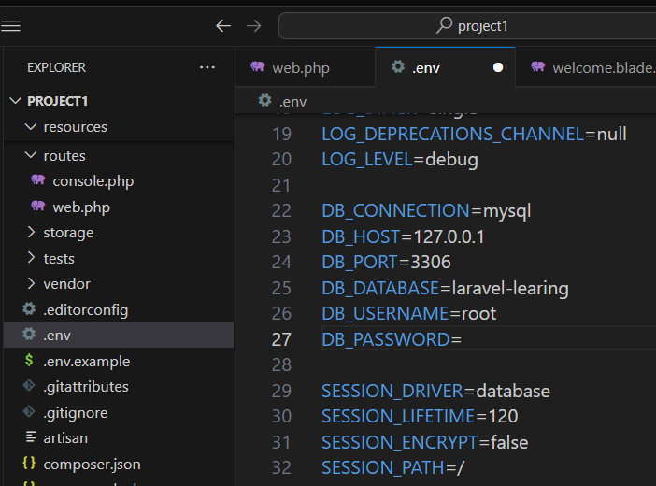

Model making commands –



Make controller –



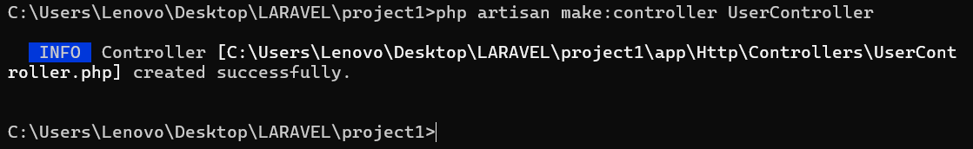

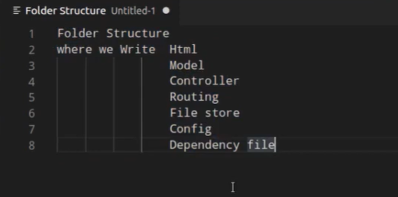

**App Folder** – Iska use Application ka core code likhte hai

* controller
* Middleware
* Models

**Kernel Folder** – Iska use me hum custom commands likhte hai.

Controller , model make ke liye commands

**Http** – Controller , Middleware

1. **Middleware** – filter lgane ke liye . like as user hai y nahi
2. **Kernel** – Iska use middleware ko register krnw ke liye use aata hai.
3. **Models** – Iska use connection krne ke liye use hota

Dtabase ke conntection file ke liye use hota hai .

**Provider** – Iska use Authntication ke liye hota hai.

Login, routing ke service provider ke liye use hota hai.

**Bootstrap** – aap.js 🡪 appki application ko load karne ke kaam aati hai , vo bhi html ke sath .

**Config** – Iski file ka use configuration kr use krne ke liye krte hai

**Database** – dummy, migration, factor all are mentioned here.

**Public** – All public file rakhte hai,

**CSS ,JS BOOTSTRAP,CSS FILES** rakhte hai.

**htaccess -** htaccess file ka use **[ url ]** ke configuration ko change akrne ke liye use .

krte hai.

**Resources** – uncompleted files rakhte hai .

**Routes** – all routes

**Test** – test cases ke liye.

**Routing**

1. **What is Routing.**
2. **How to make routing.**
3. **Pass data with Routing.**
4. **Anchor tag**
5. **Redirect**

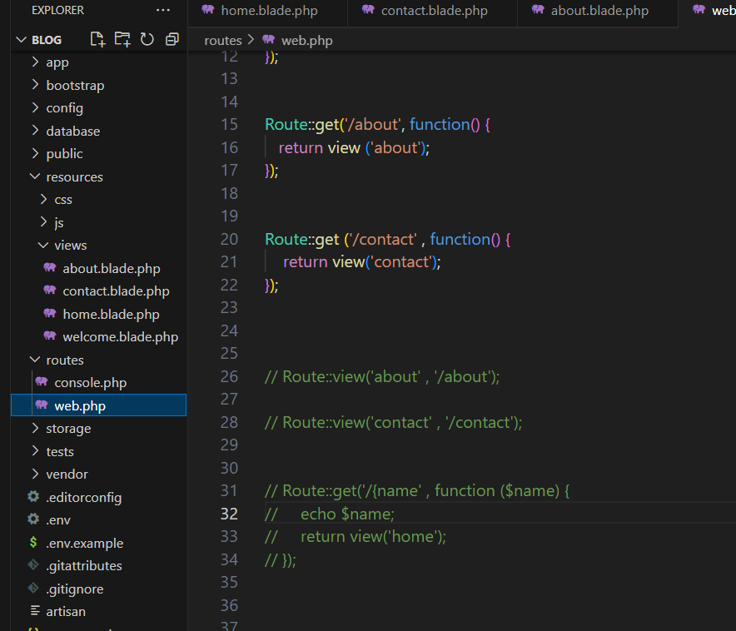

**Controller**

Model, view, and controller ko control krne ke liye use krte hai.

Route files me kis file ko **view krana** hai kisko nhi ye kaam bhi controller hi karta hai.

* **php artisan make:controller UserController**

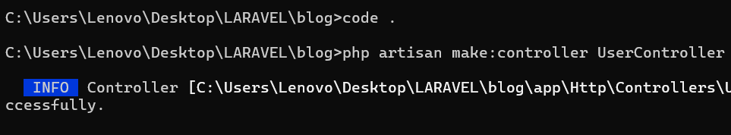

Laravel me controller ko web.php me import krna pdta hai sabse pahle.

Call karna padta hai sabse pahle controller ko.

Import userController in web.php –

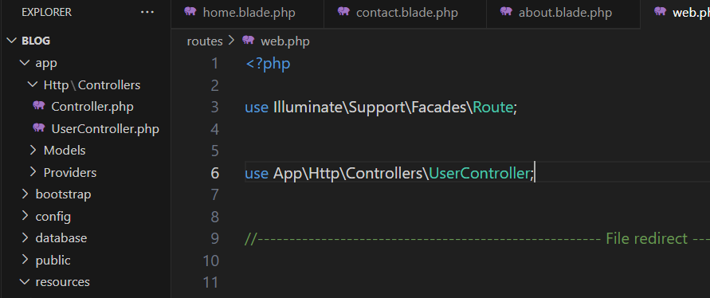

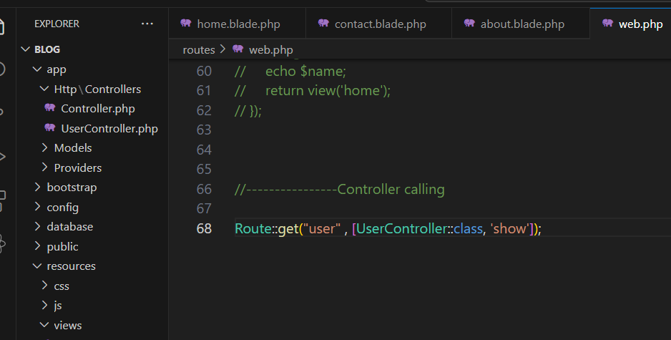

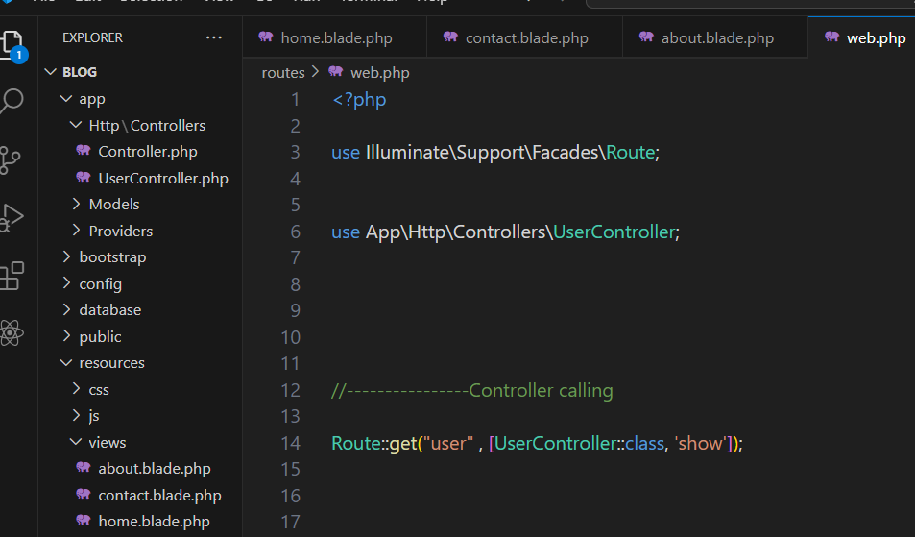

**Laravel 7 – Controller calling**

* Route::get('users','UserController@show');

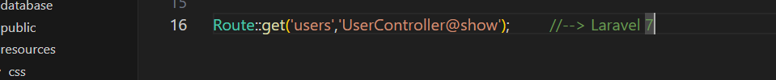

**COMPONENT –**

2 jagah component banta hai ek ***[*** *resources – view – component****]*** ***ComponentName.blade.php*** and second ***[*** *app – view – component****] ComponentName.php*** me ek app me.

**Php artisan meke:component Header**

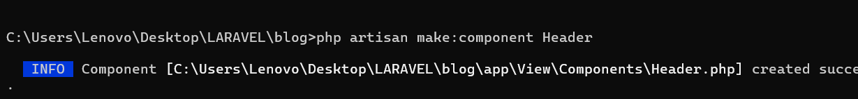

**File 🡪**

resources – view – components -> header.blade.php

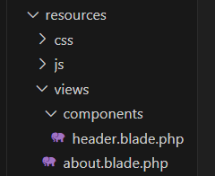

App – view – components – header.php

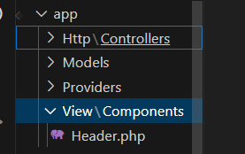

**Calling component –**

<x-header/>

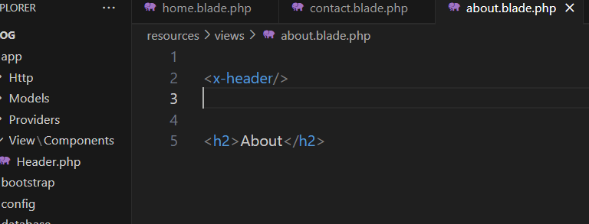

**Write the code of component created for showing codes………….**

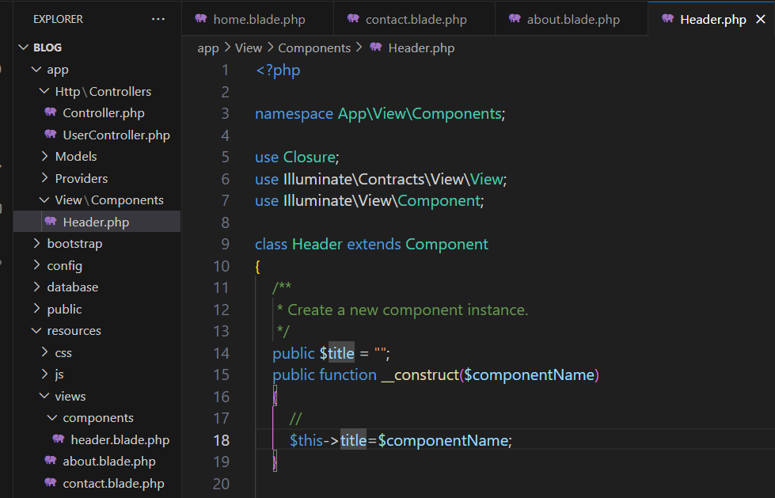

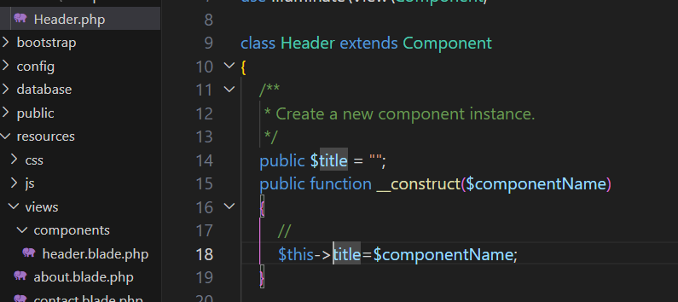

Pass the component name according to page files.

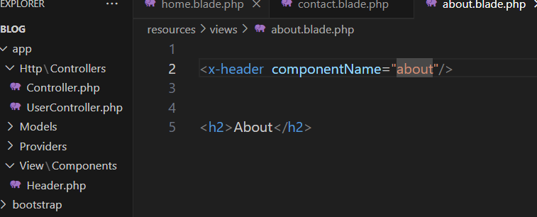

Show the component according to page name

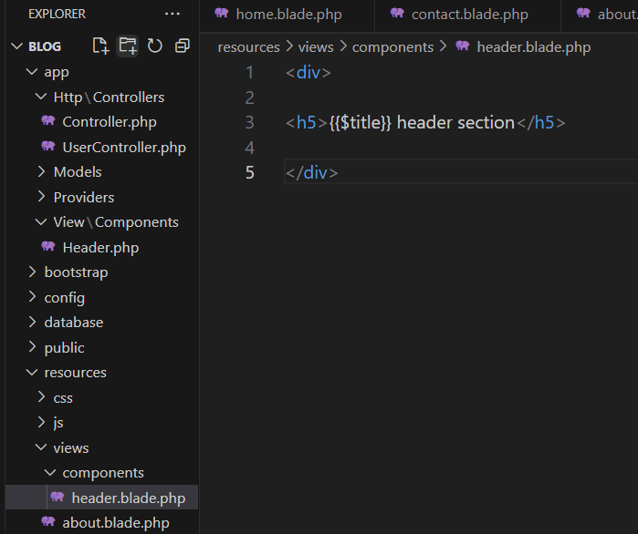

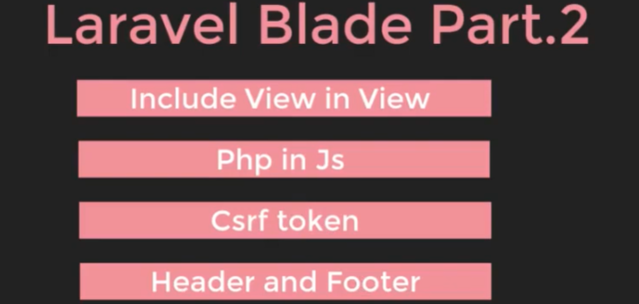

* Use as a Script

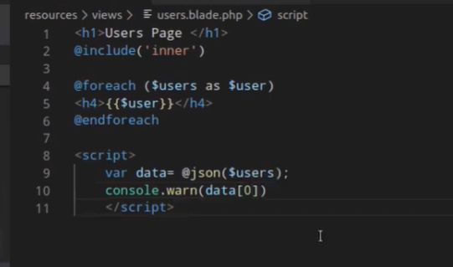

**Function** –

*@include* function

**@csrf** 🡪 secure form ke liye use krte hai , token create karne ke liye jisse koi hack nahi kar sake koi hackers.

HTML Form –